TASK
TASK - 15

Contents
Question 1: 10 Linux Commands

Question 2: Snowflake: Loading CSV and Performing Operations

Question 3: VPC Creation

Question 1: 10 Linux Commands
Ten Linux commands run in a terminal session, shown in two screenshots.
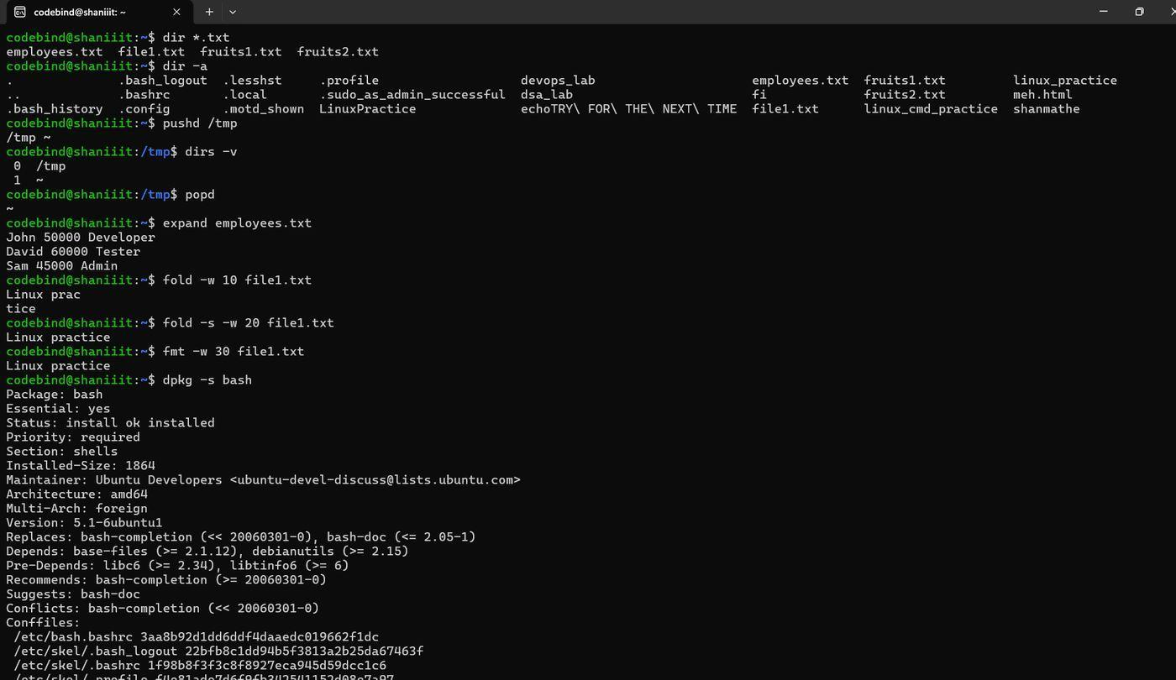

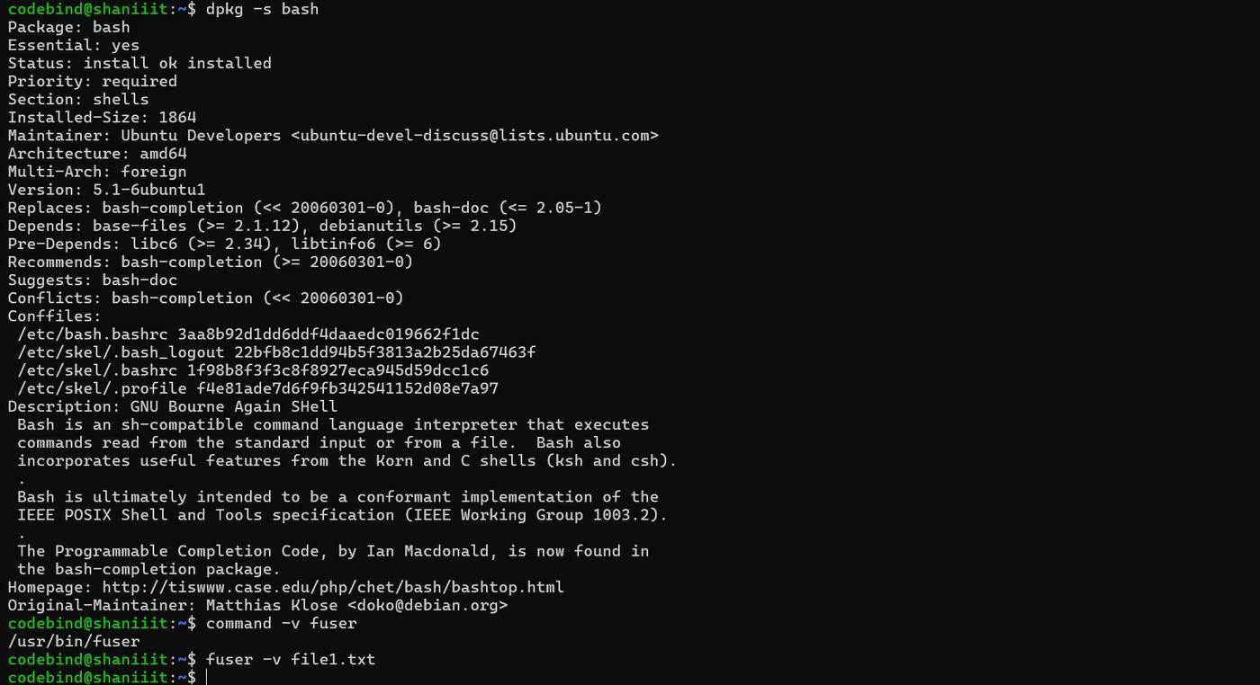

Question 2: Snowflake: Loading CSV and Performing Operations

Create and Select Database
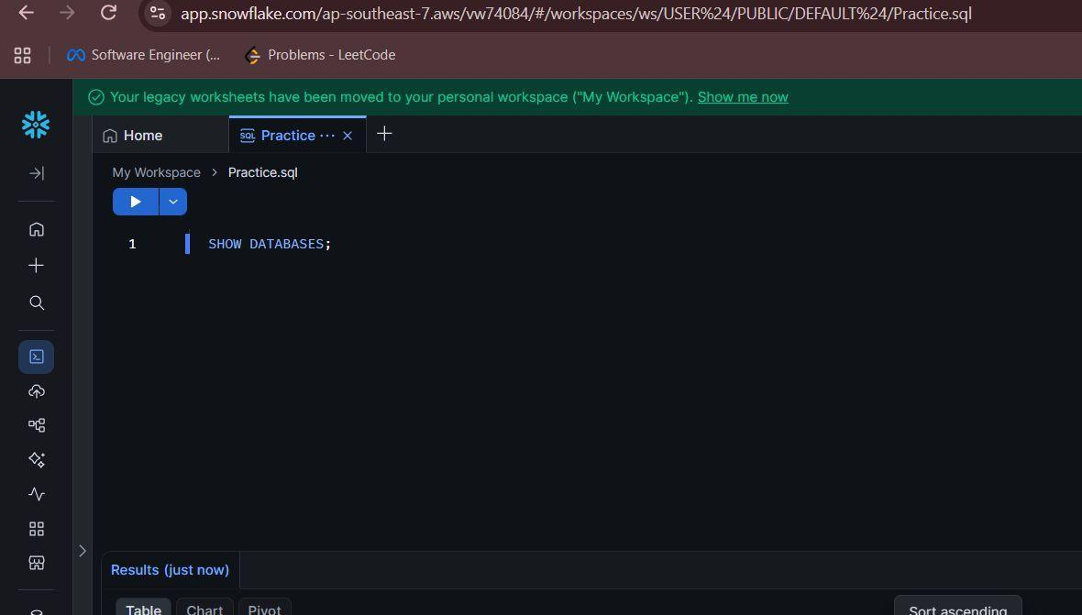
Figure 3. Opening the worksheet

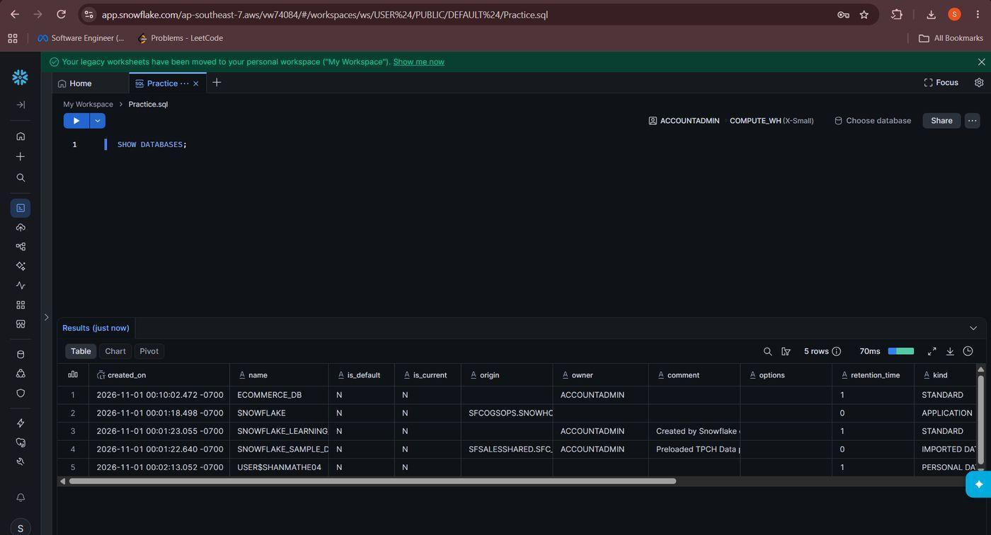
Figure 4. Listing existing databases

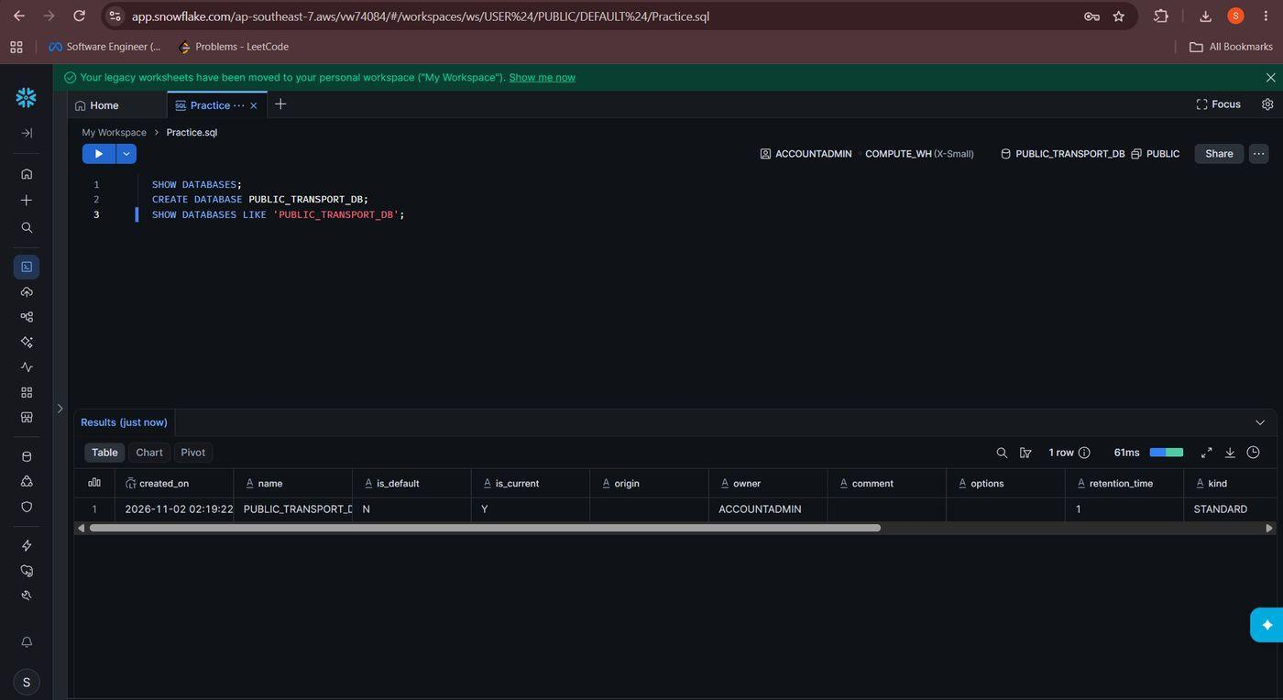
Figure 5. Creating PUBLIC_TRANSPORT_DB

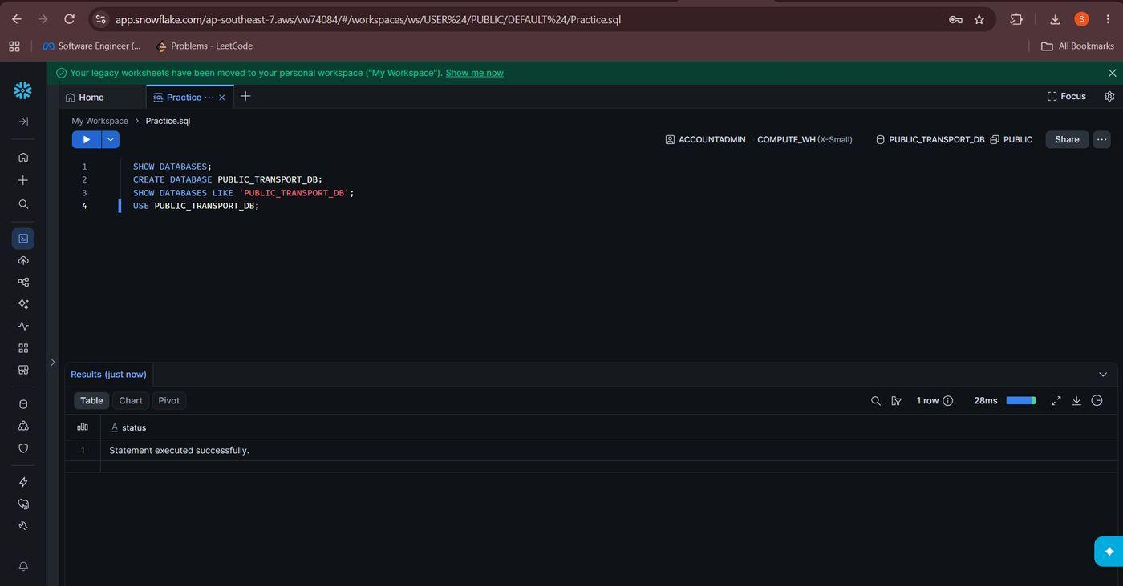
Figure 6. Selecting the database

Create Schema
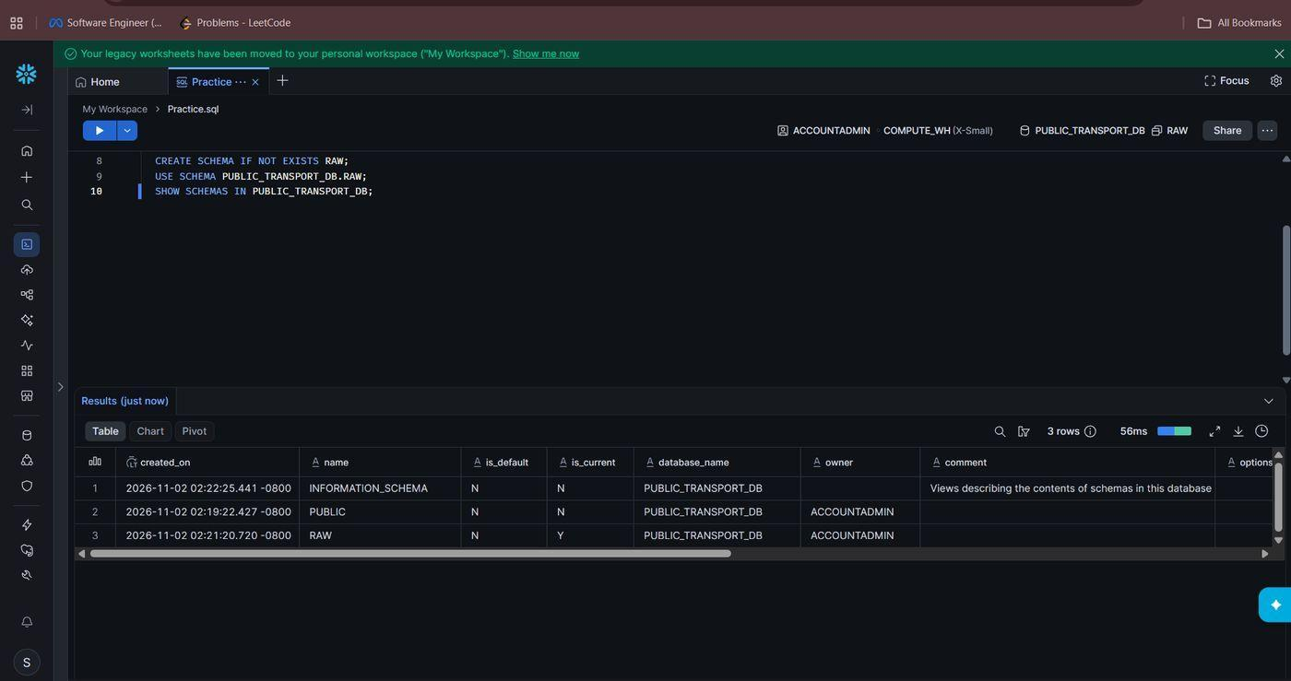
Figure 7. Creating the RAW schema

Create Warehouse
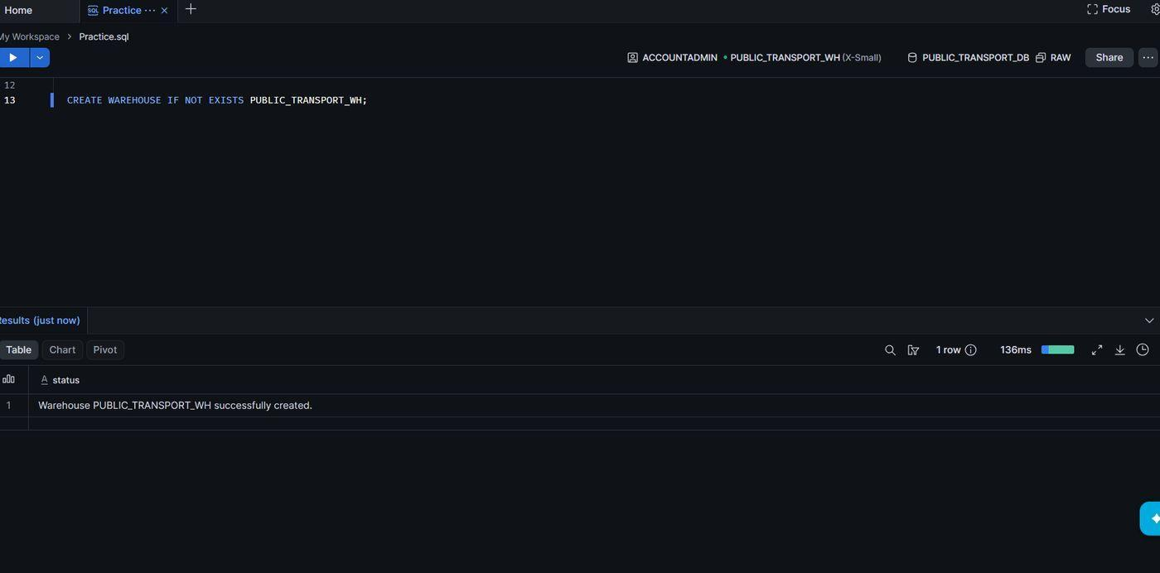
Figure 8. Creating the warehouse
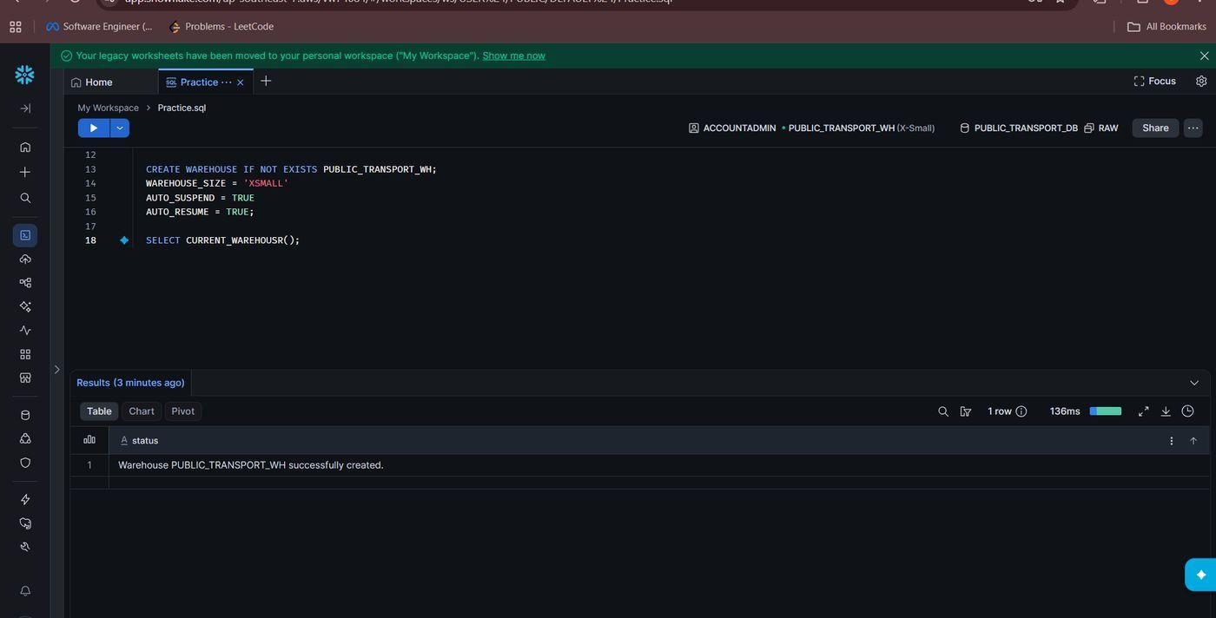
Figure 9. Adding warehouse settings

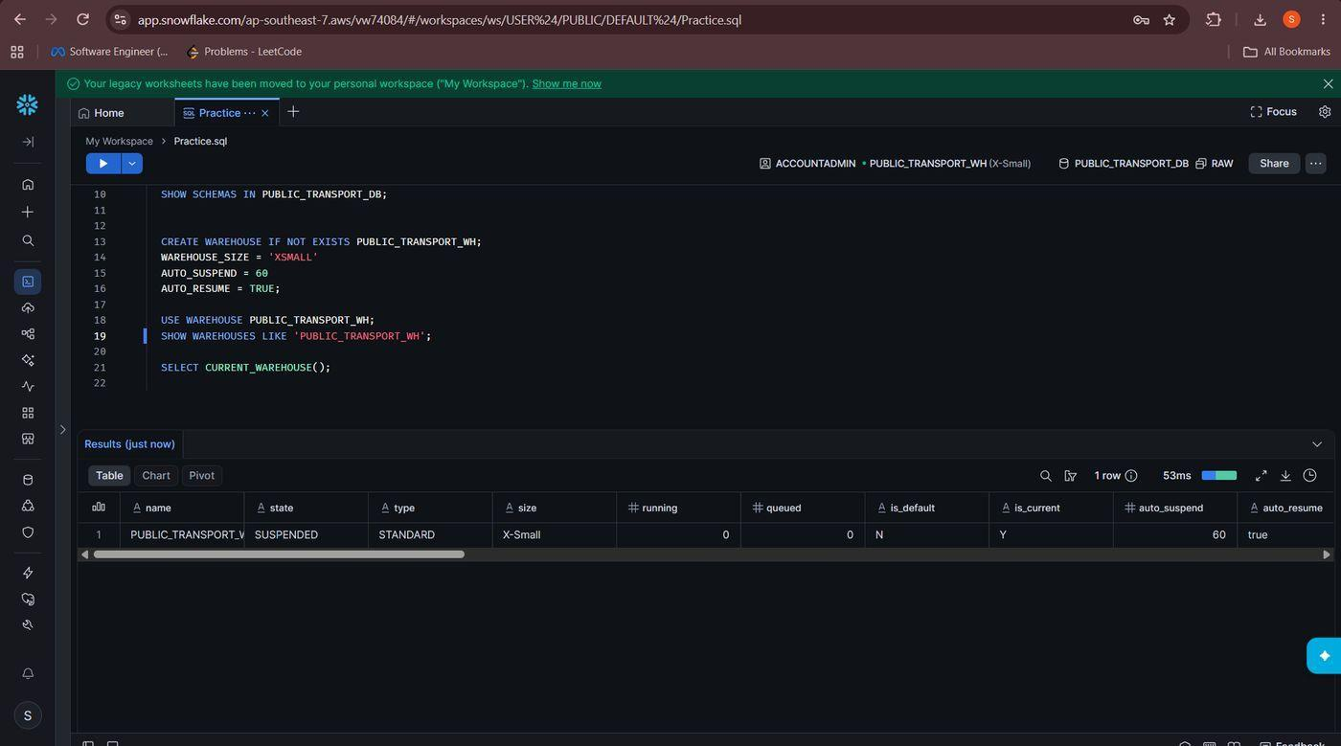
Figure 12. Checking the warehouse state

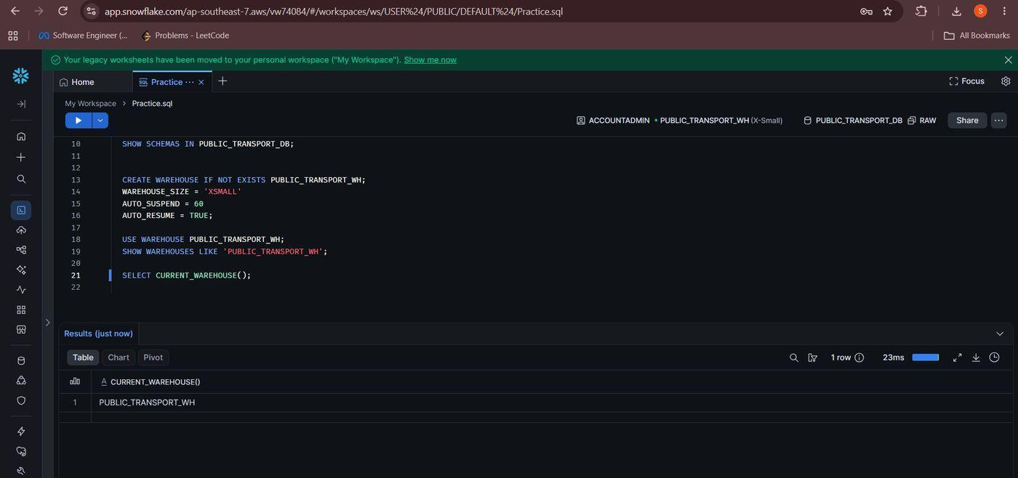
Figure 13. Confirming the active warehouse

Create Table
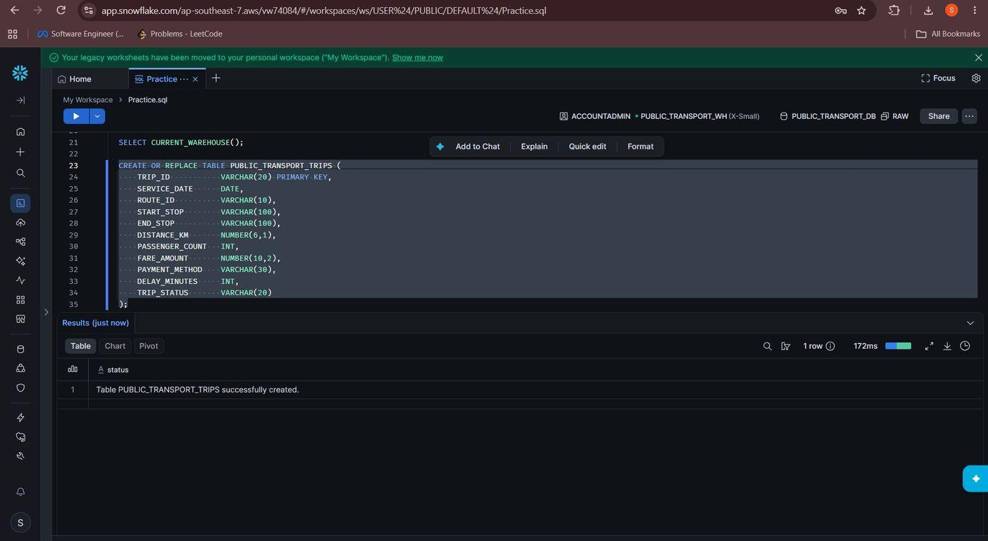
Figure 14. Creating the trips table

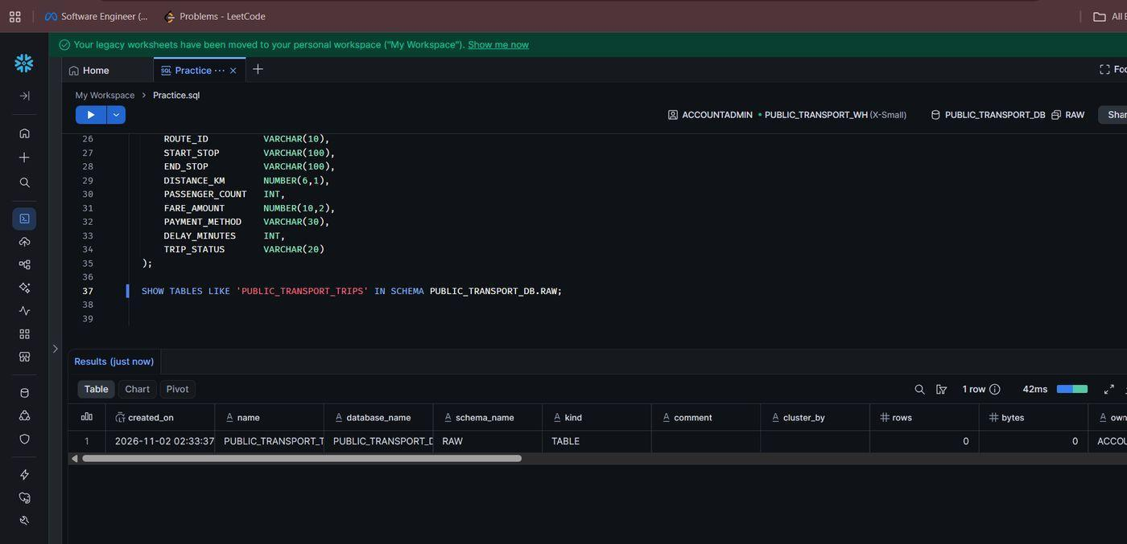
Figure 15. Verifying the table

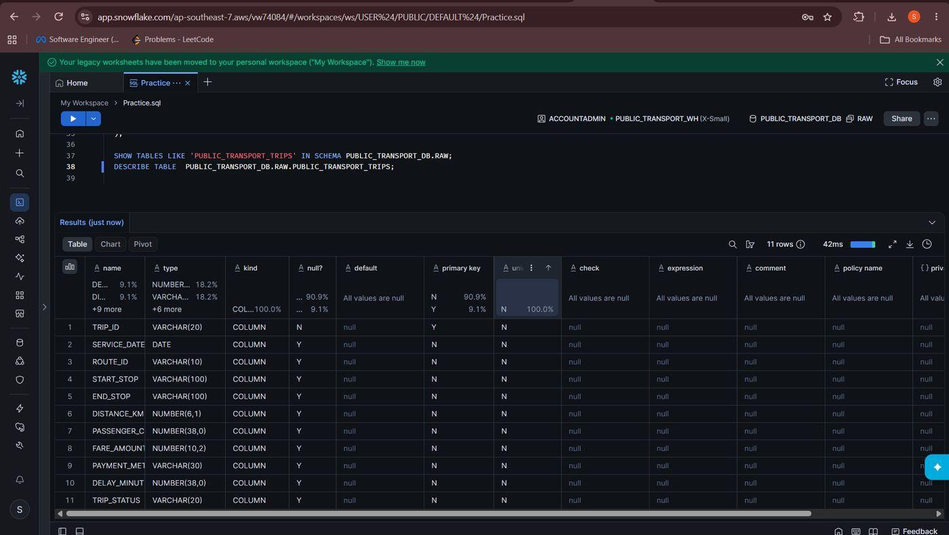
Figure 16. Describing the table structure

Create File Format
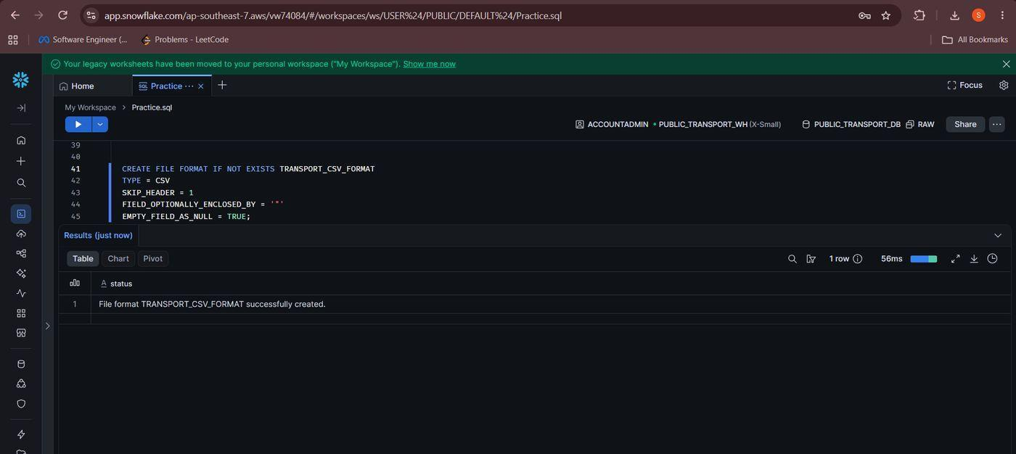
Figure 17. Defining the CSV file format

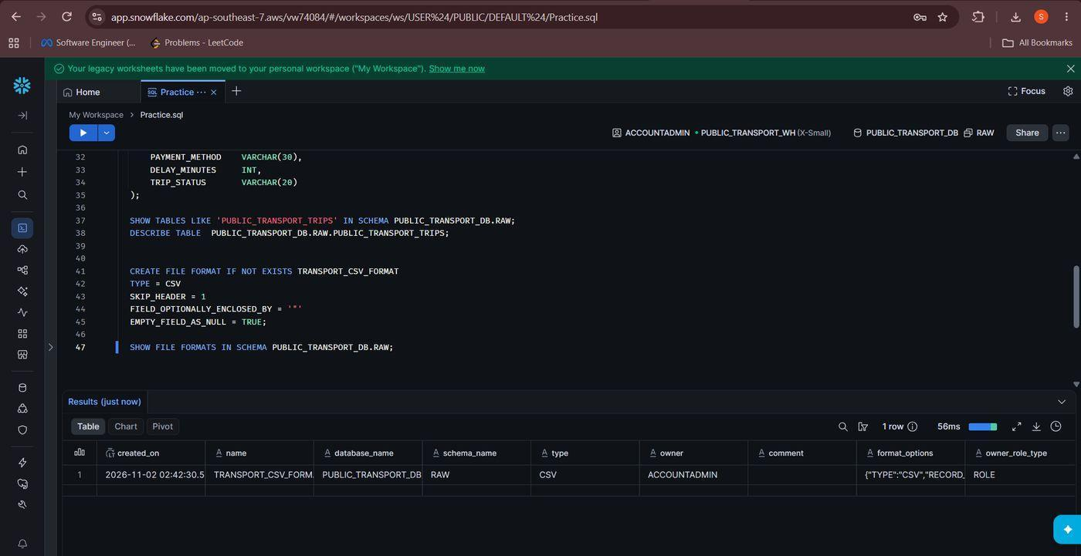
Figure 18. Verifying the file format

Create Stage
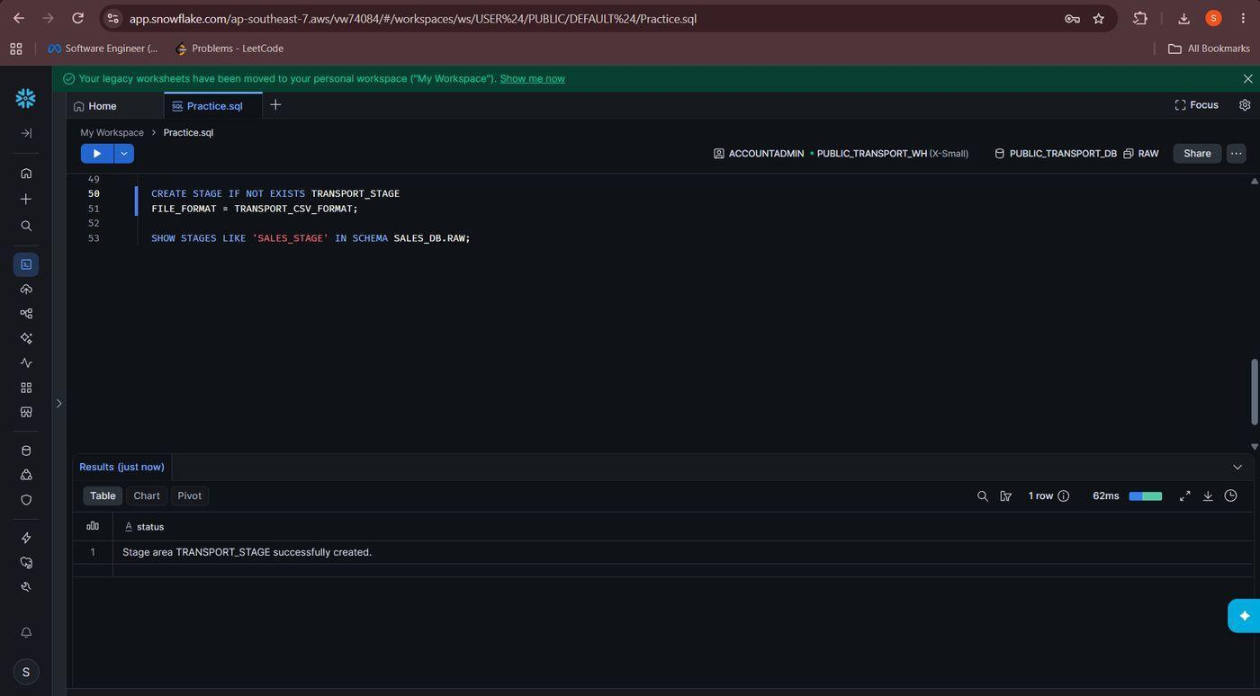
Figure 20. Creating TRANSPORT_STAGE

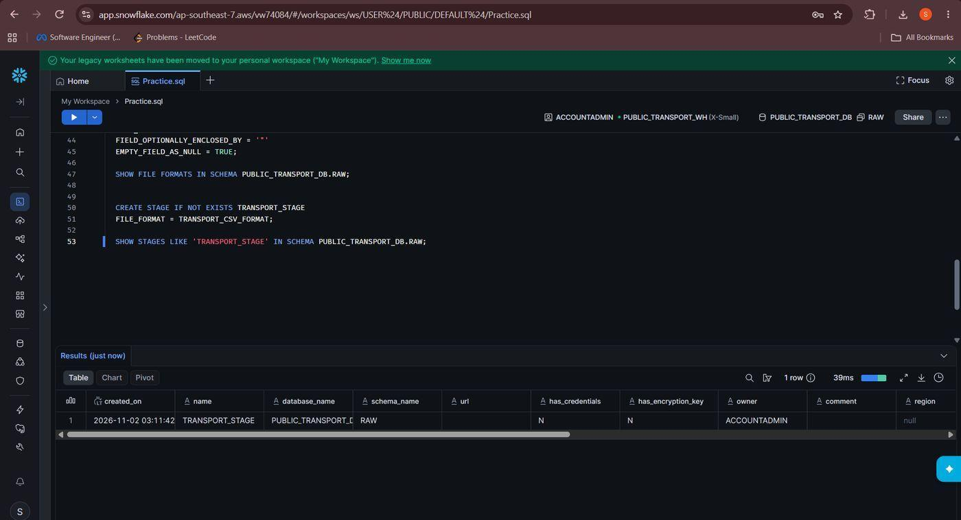
Figure 21. Verifying the stage
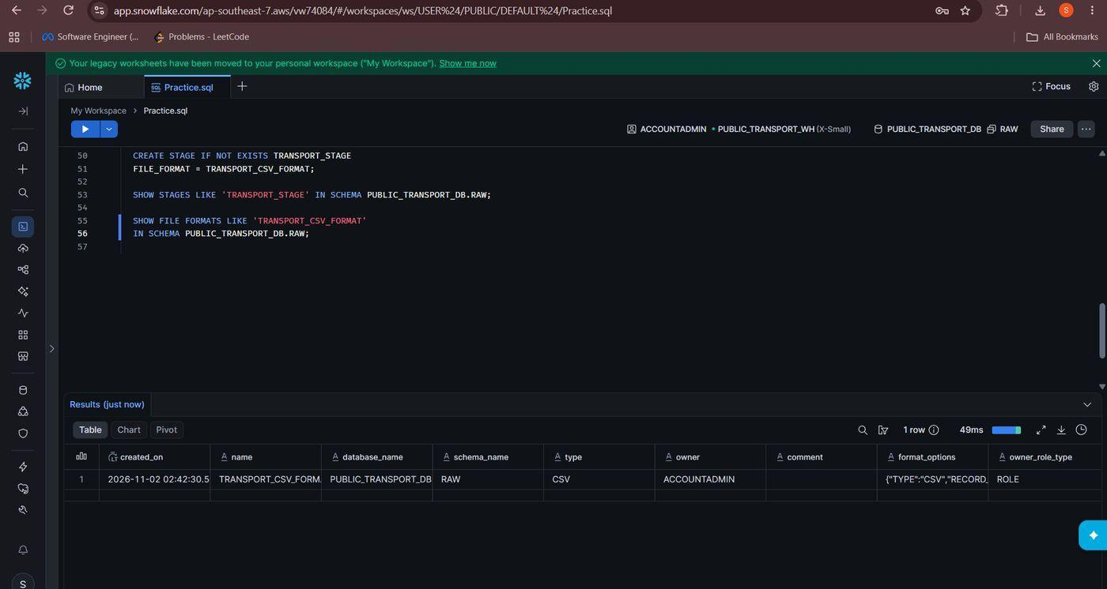
Figure 22. Re-checking the file format

Load CSV into Stage and Copy into Table
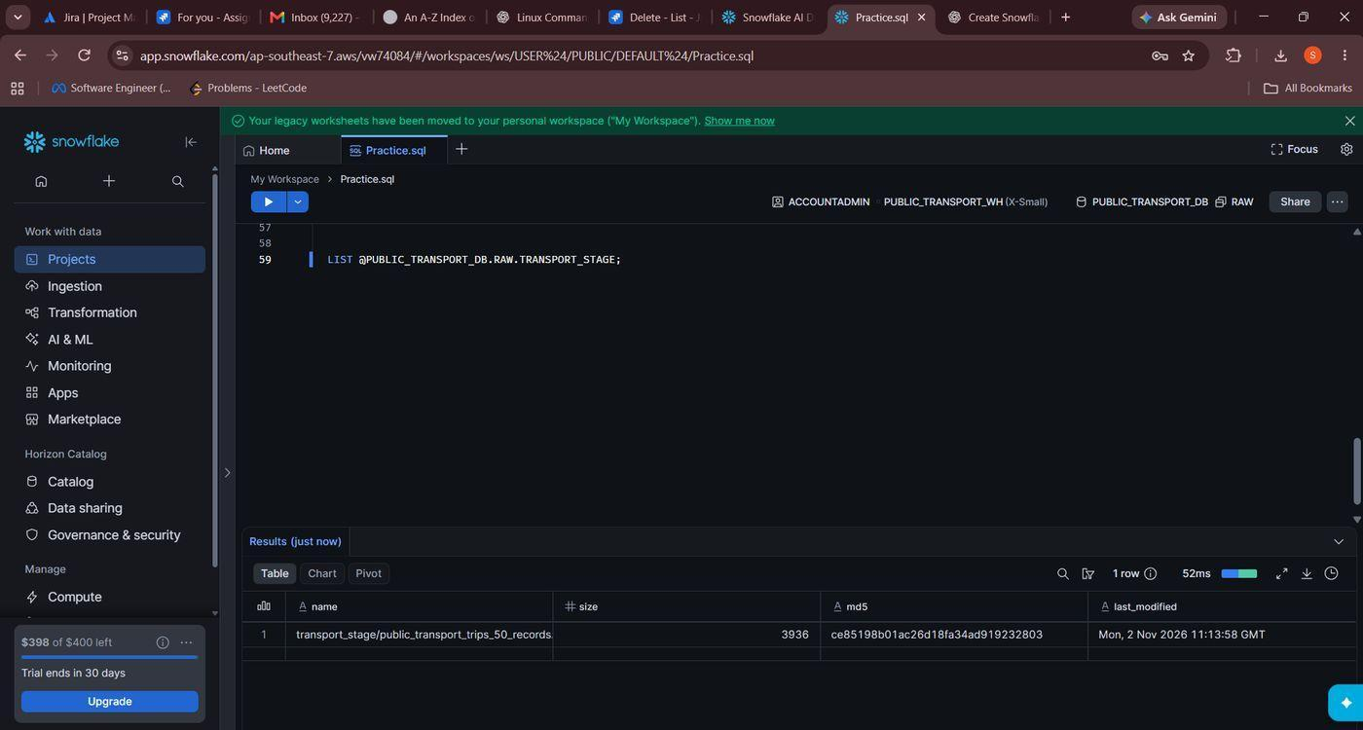
Figure 23. Listing the uploaded file
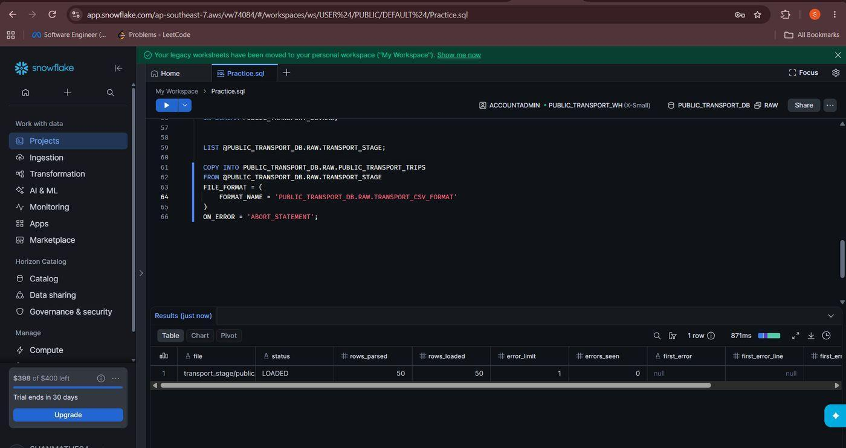
Figure 24. Loading the data with COPY INTO

Query and Analyse the Data
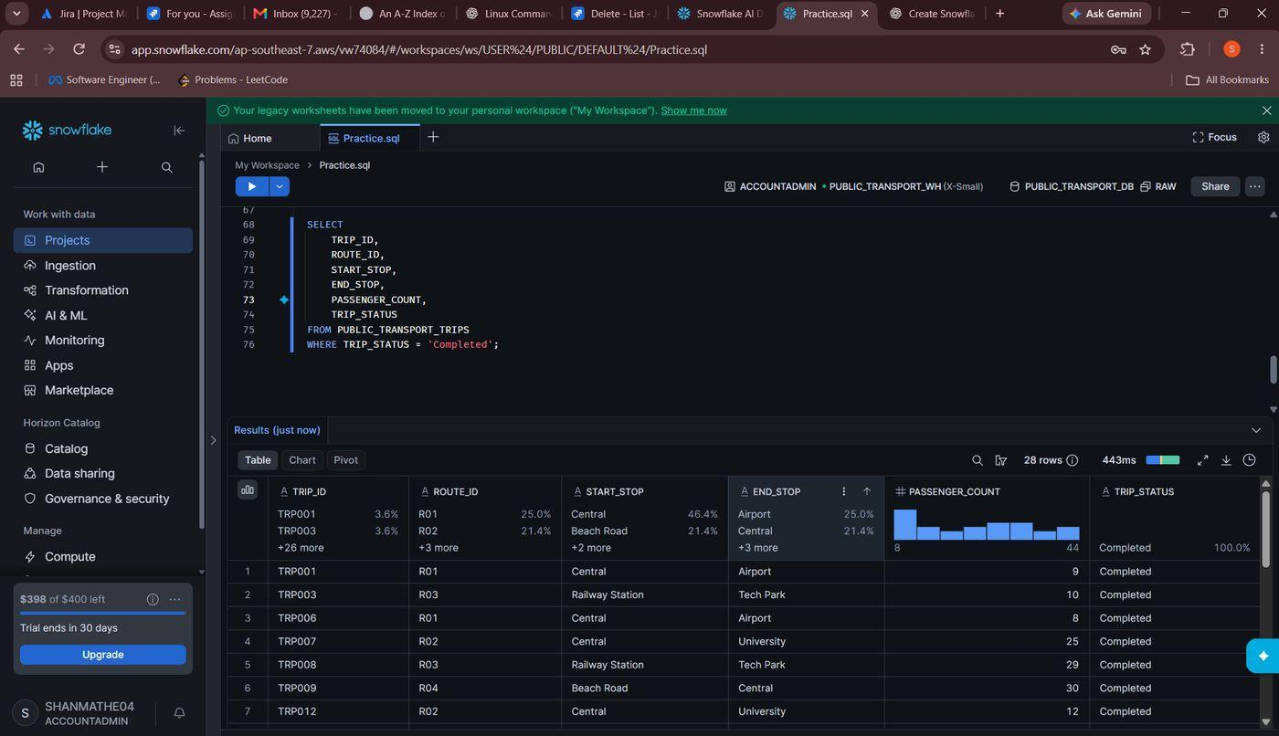
Figure 25. Completed trips
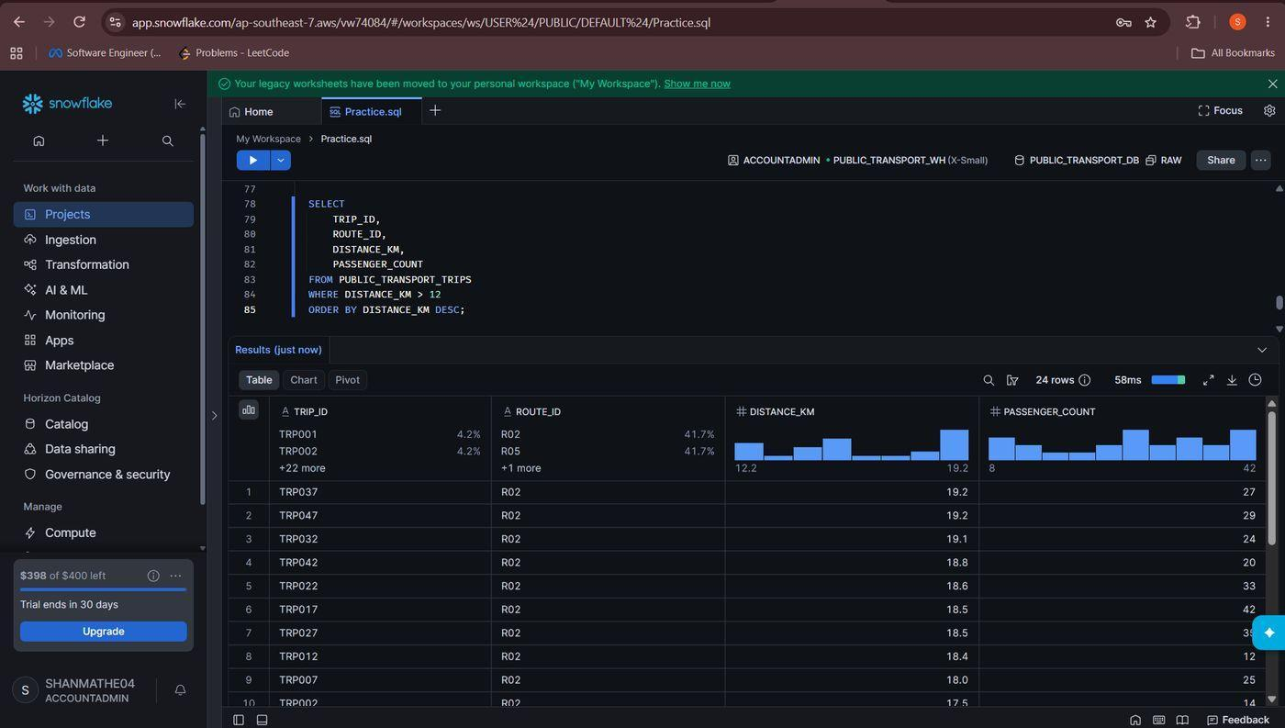
Figure 26. Long-distance trips
Trips longer than 12 km are selected with WHERE DISTANCE_KM > 12
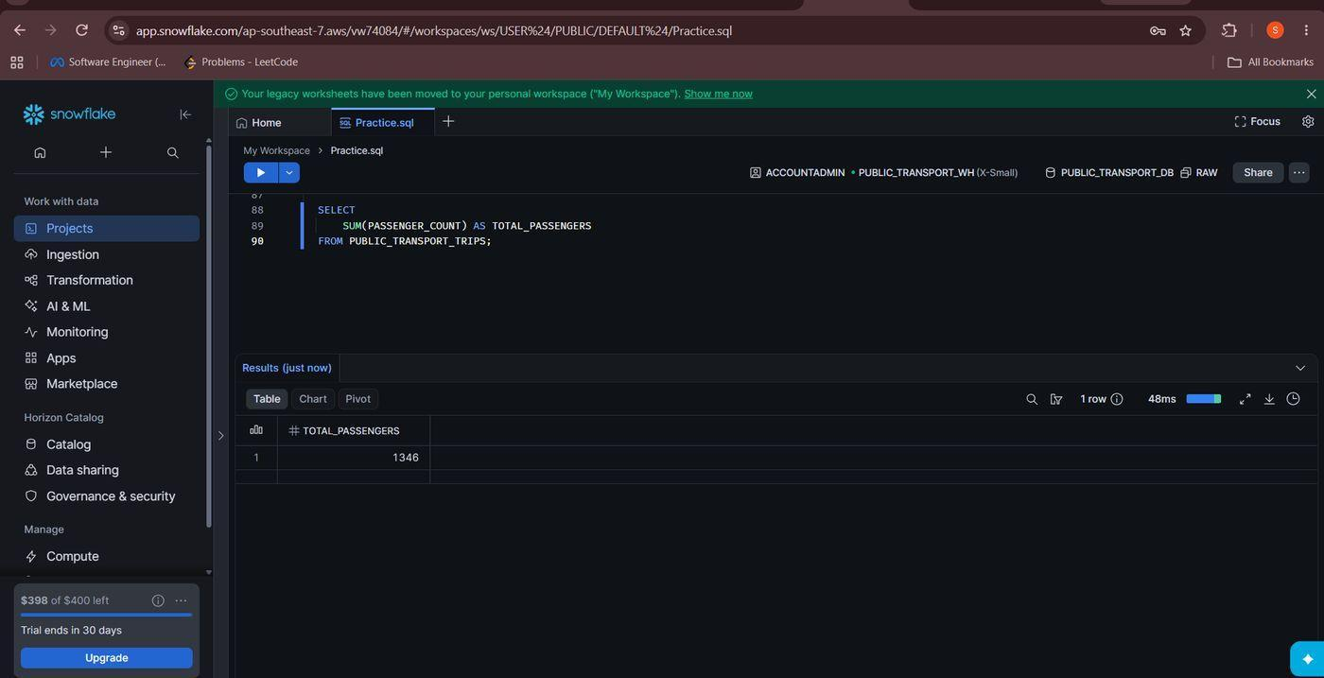
Figure 27. Total passengers
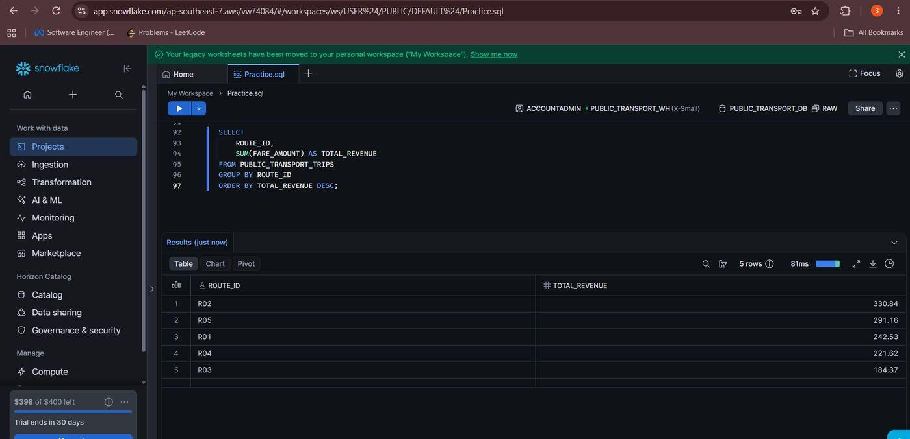
Figure 28. Revenue by route

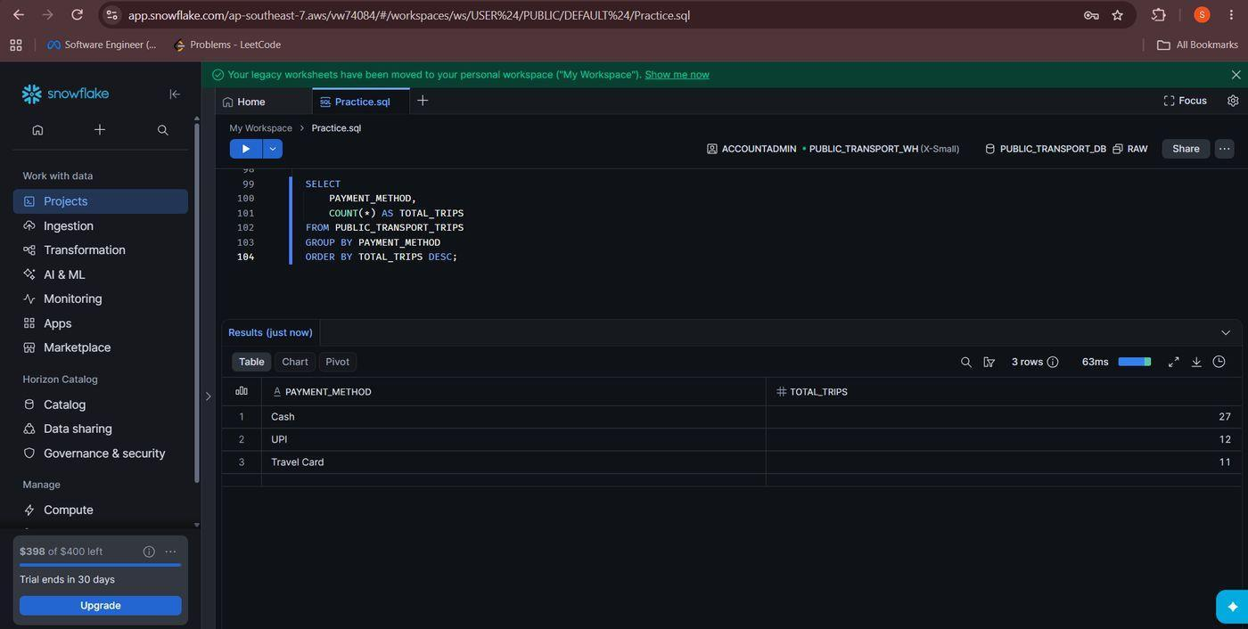
Figure 29. Trips by payment method
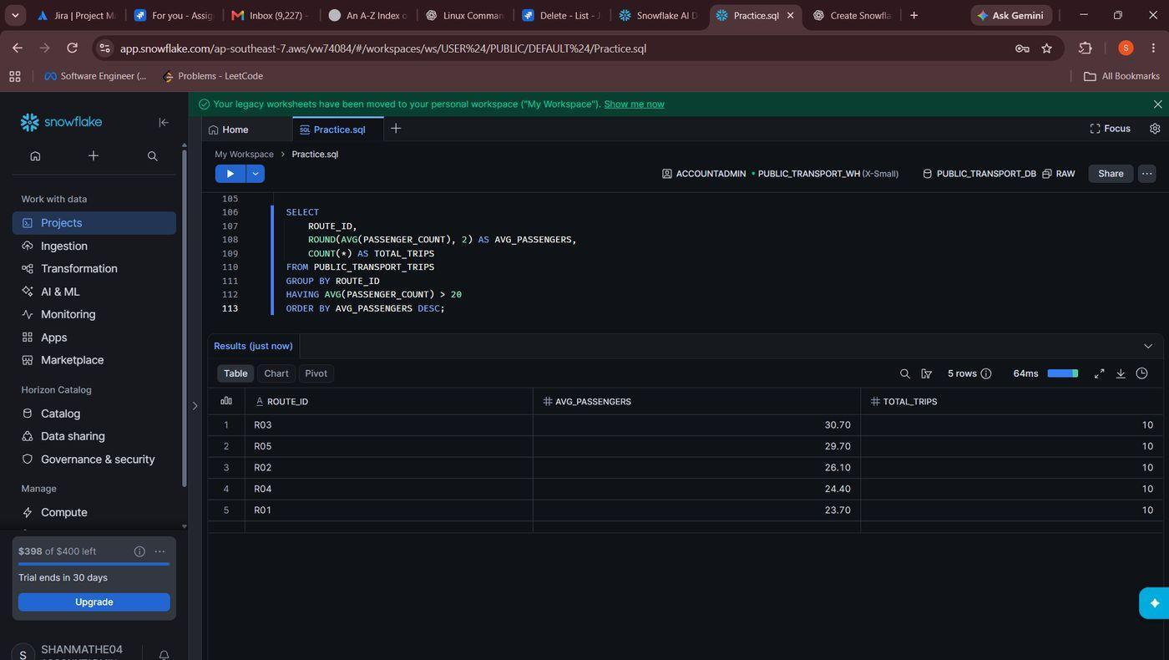
Figure 30. Average passengers per route

Cleanup
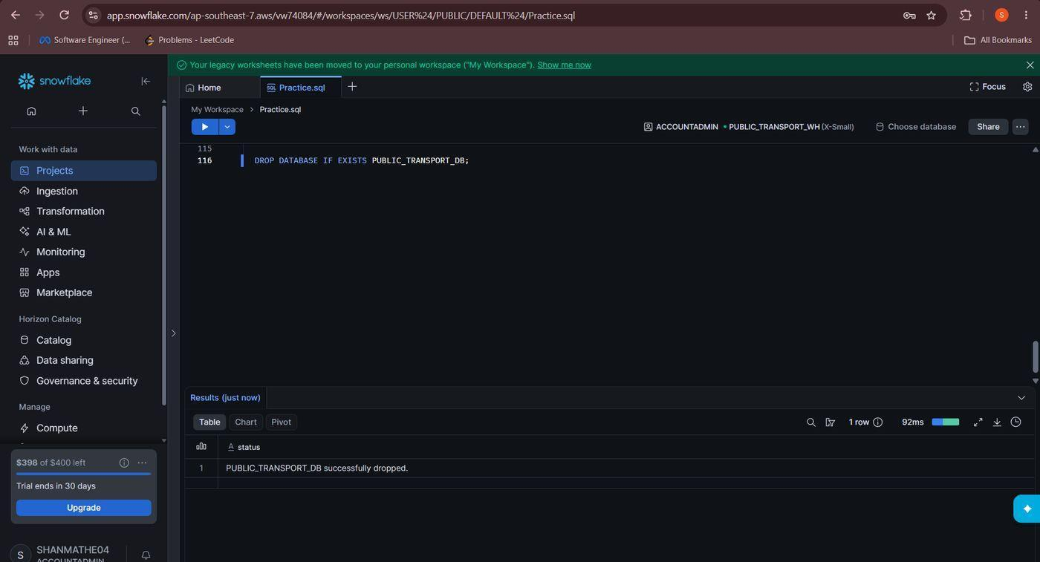
Figure 31. Dropping the database
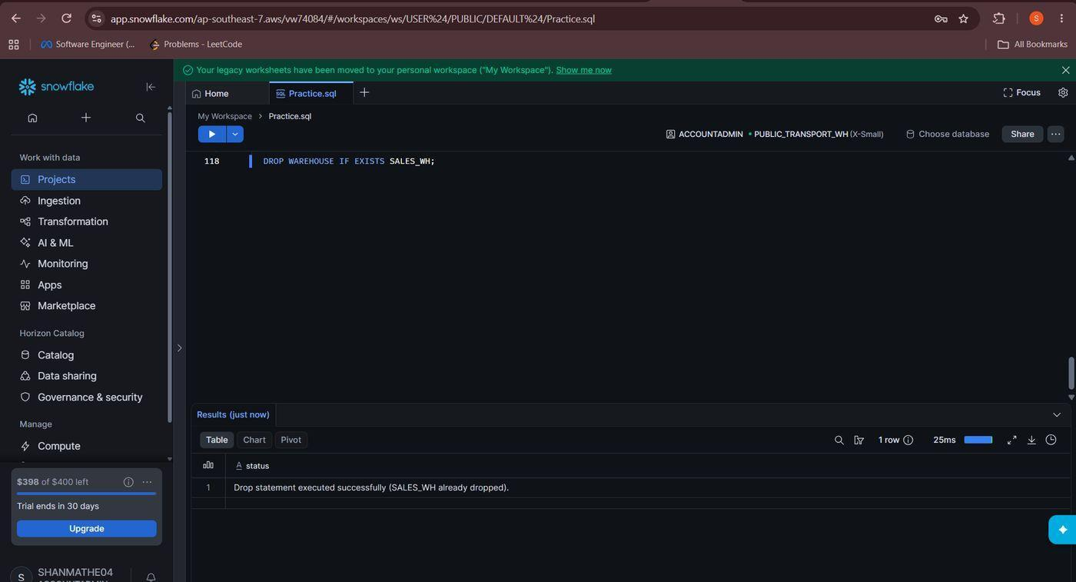
Figure 32. Dropping the warehouse

Question 3: VPC Creation

Create VPC
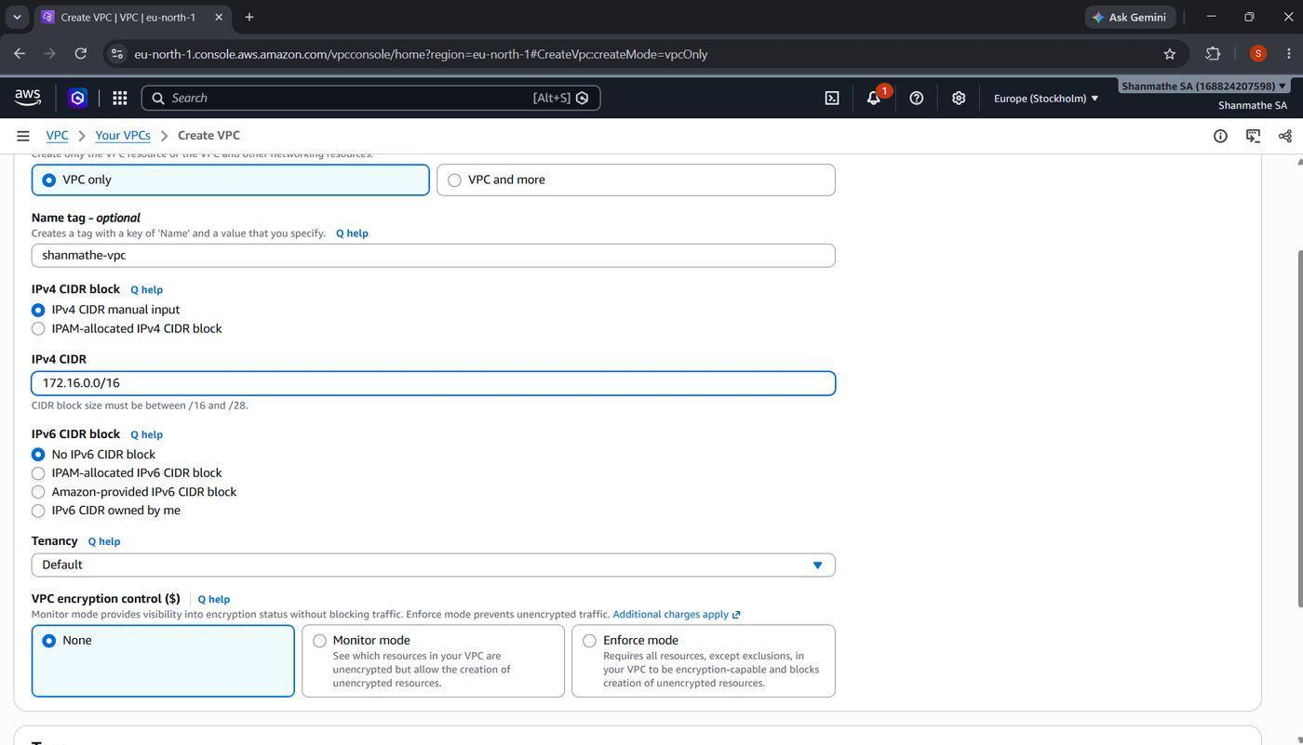

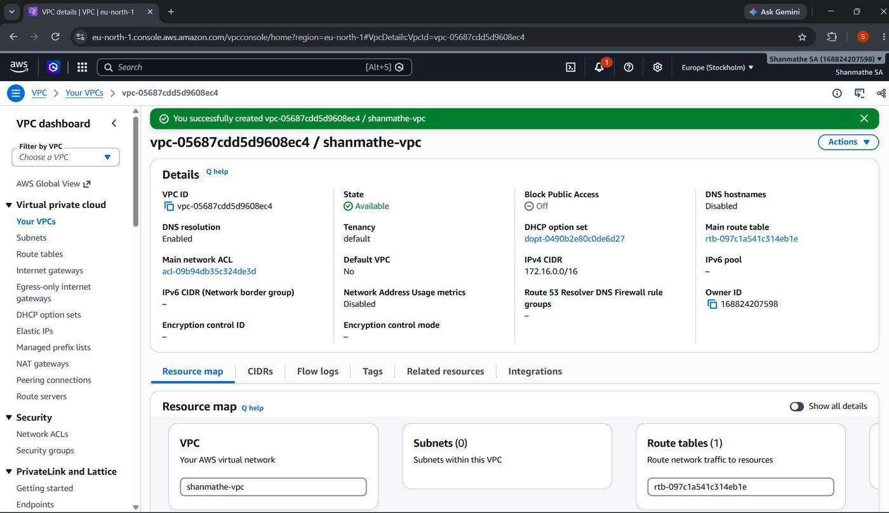

Create Subnets (Public and Private)
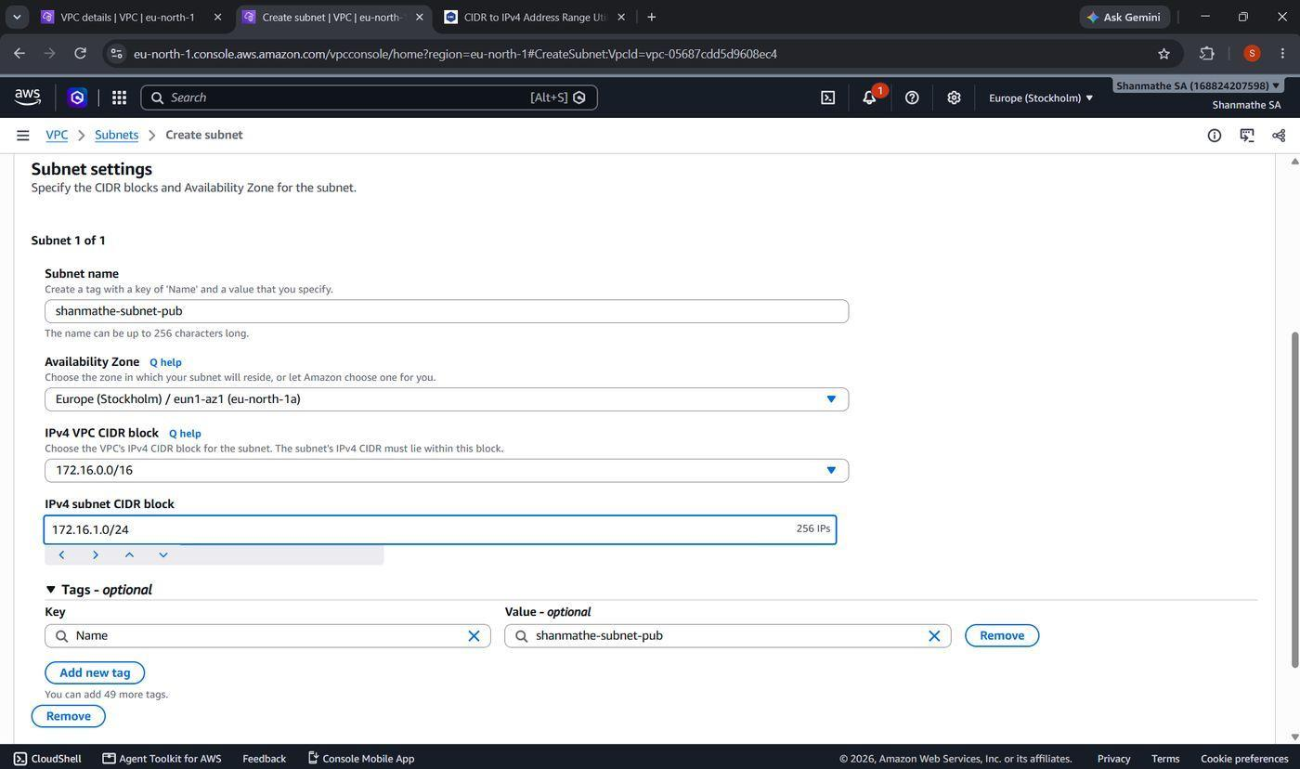

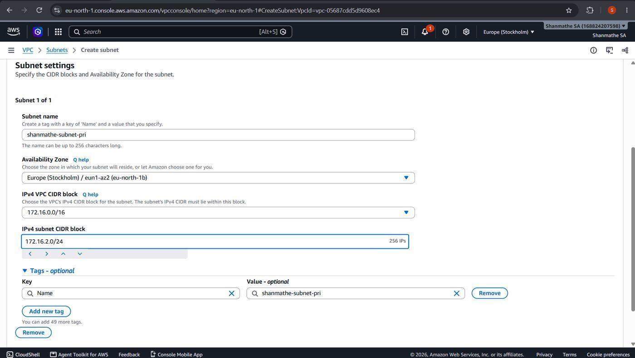

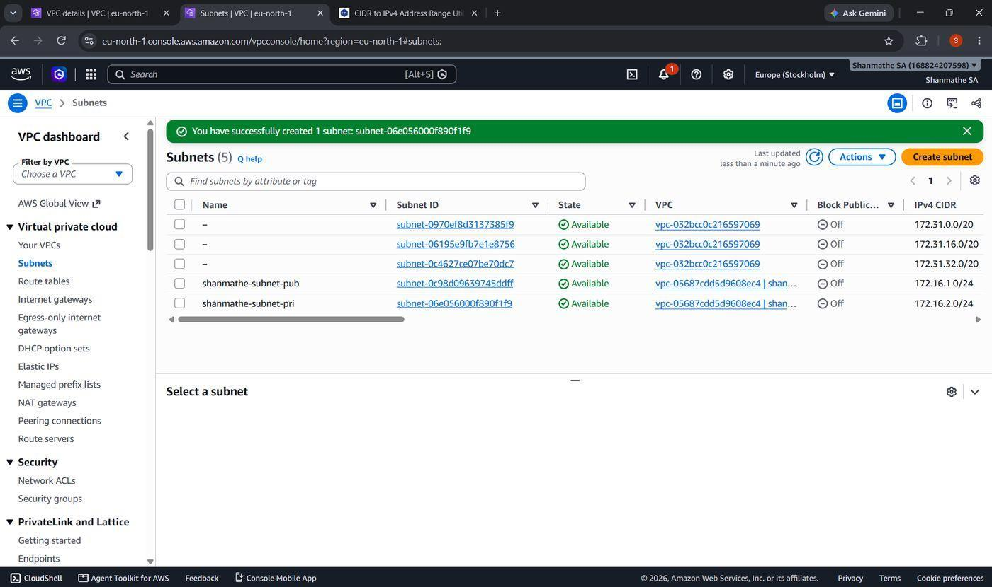

Internet Gateway and Public Route Table
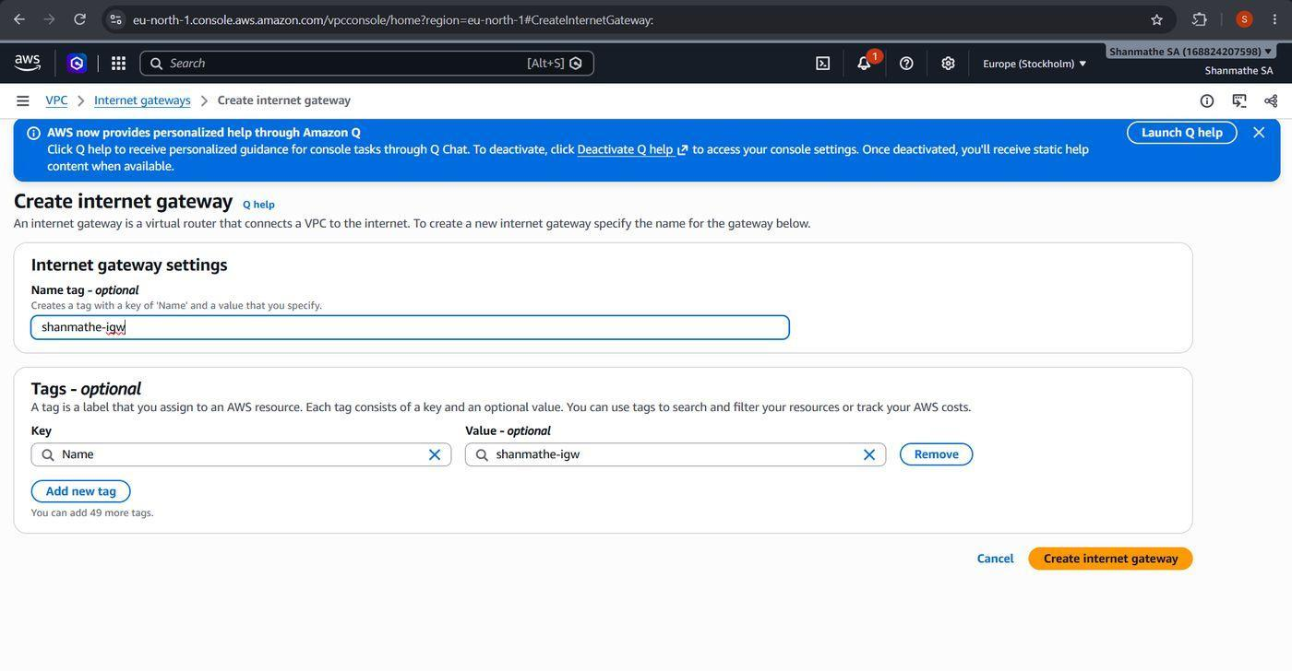

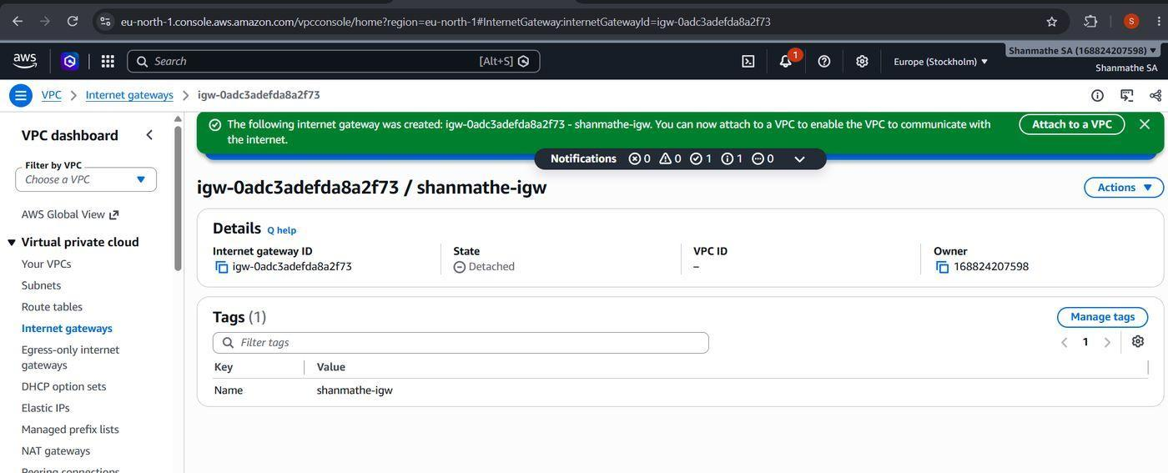

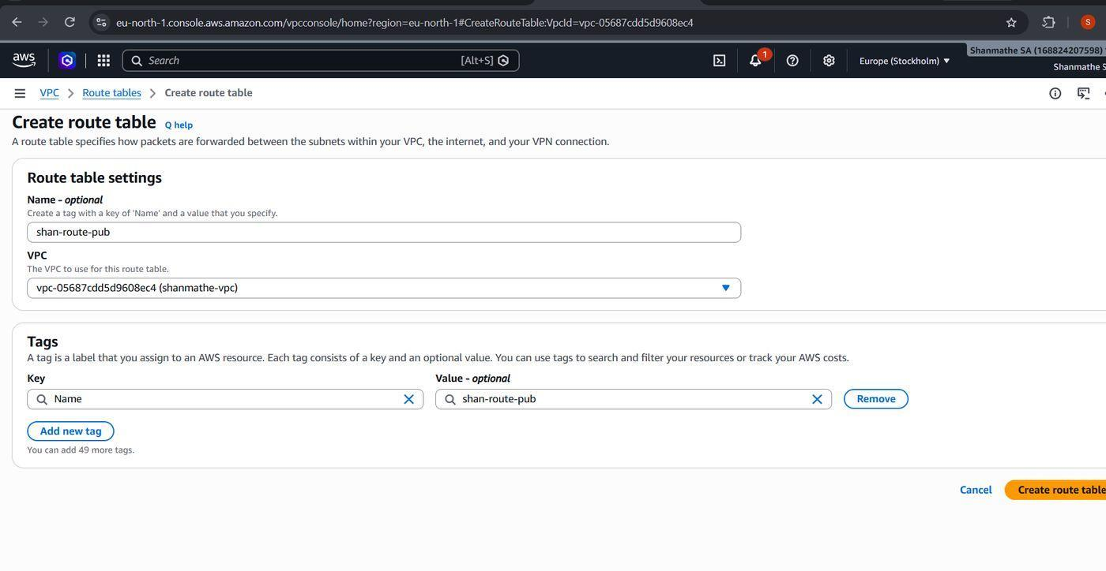

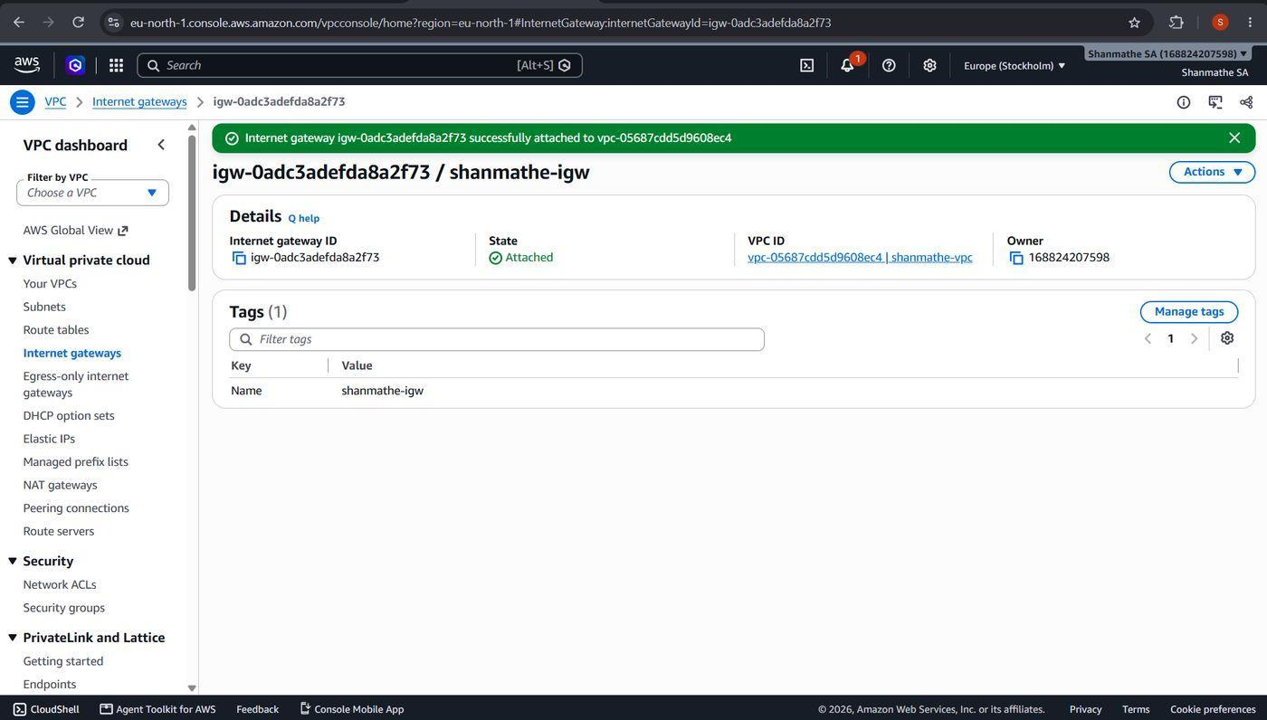

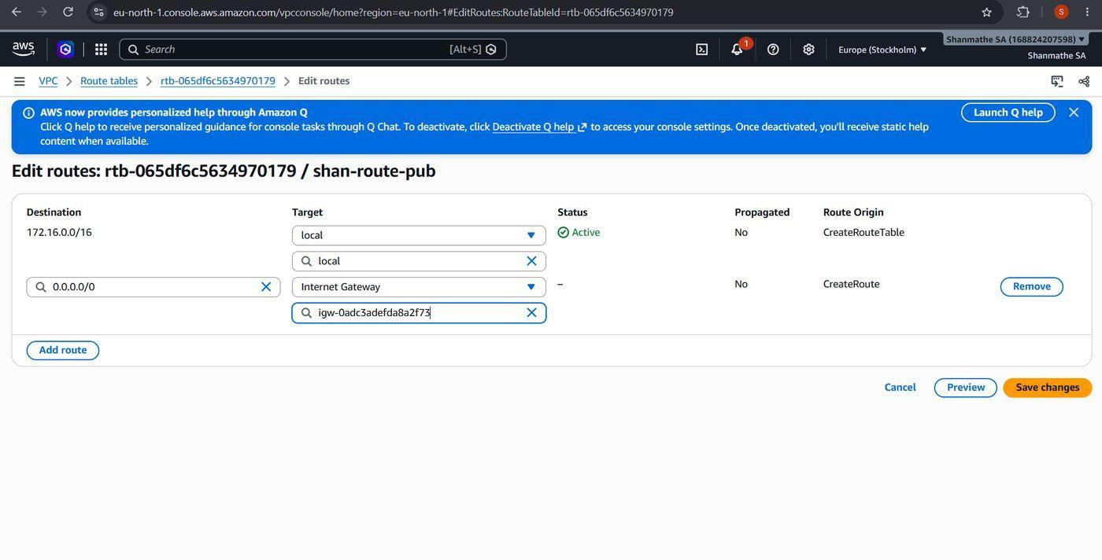

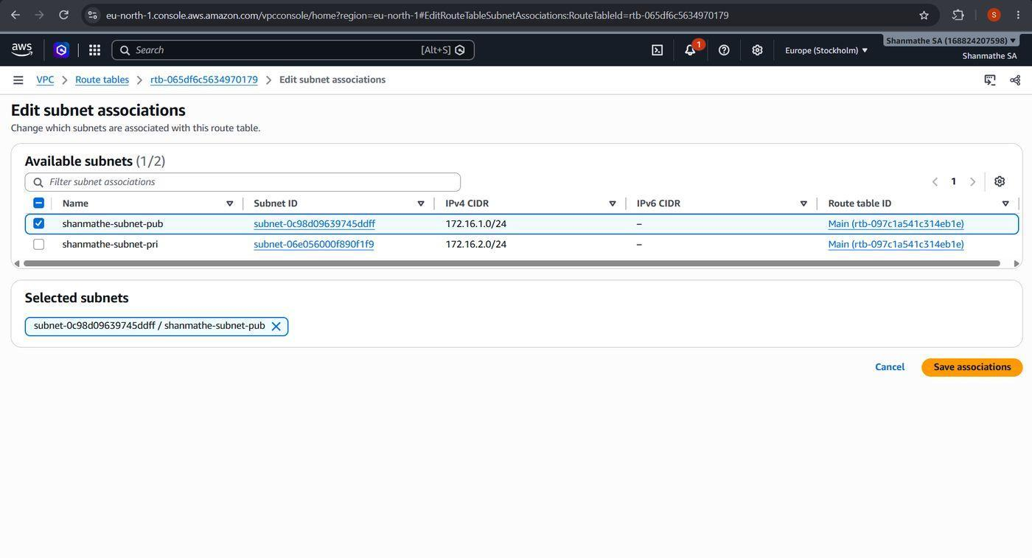

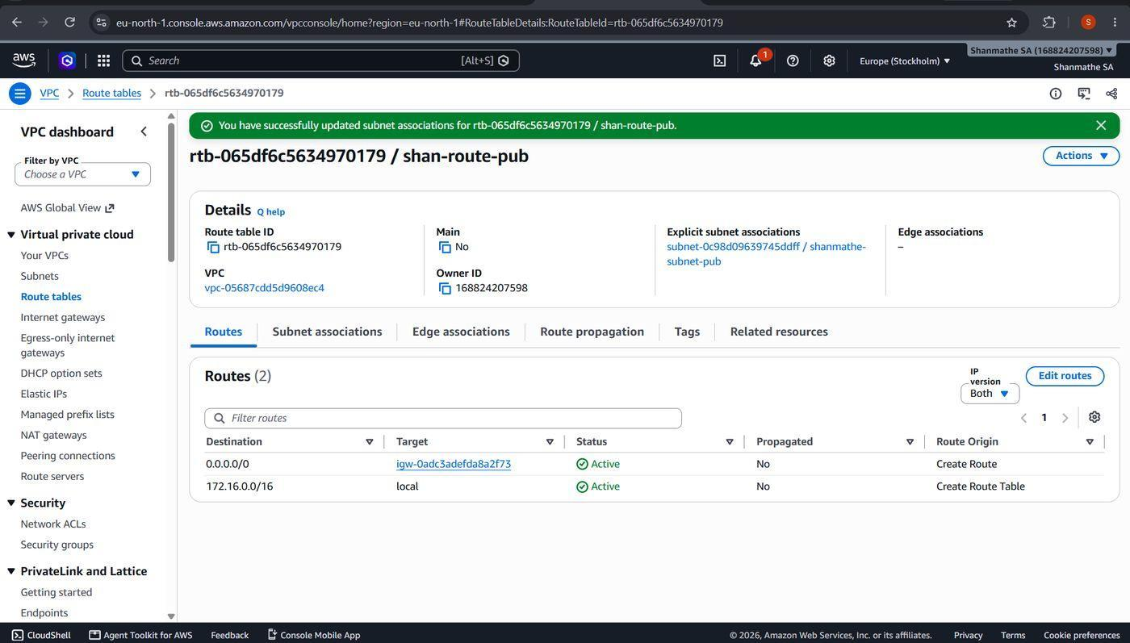

Private Route Table and NAT Gateway
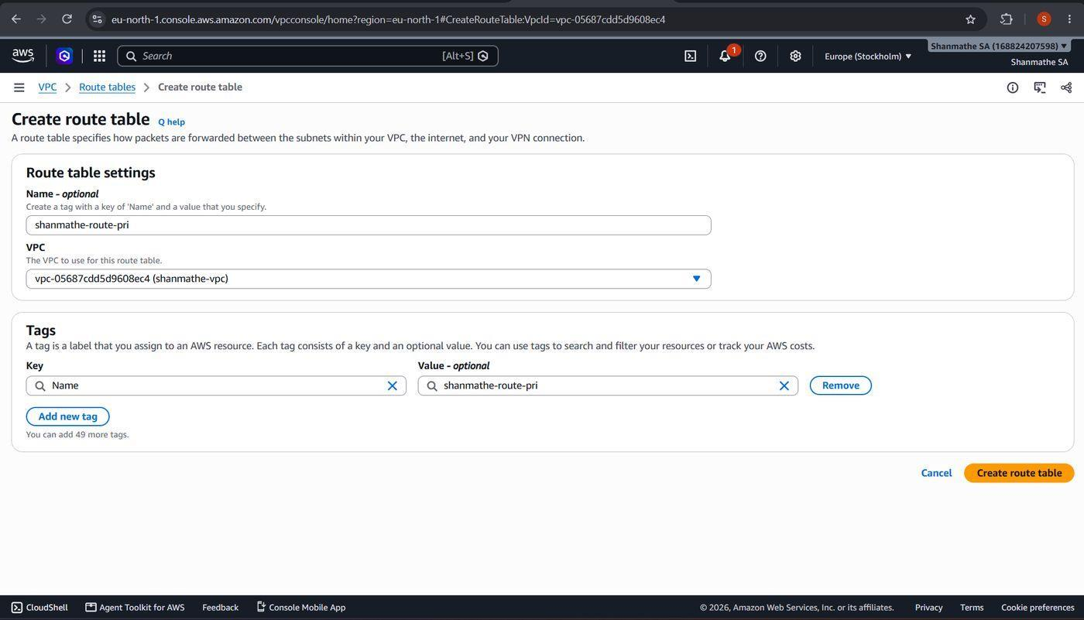

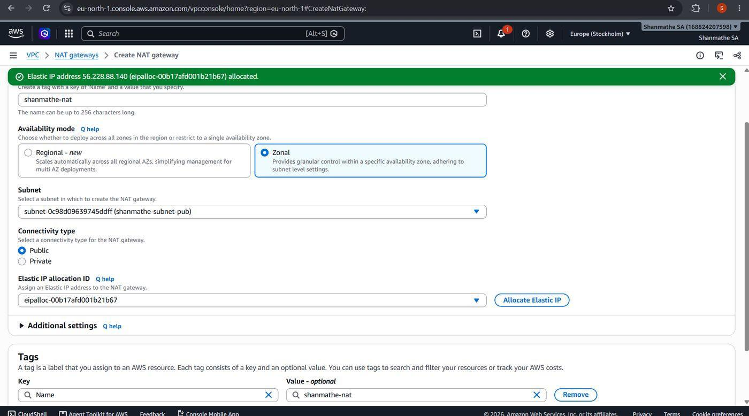

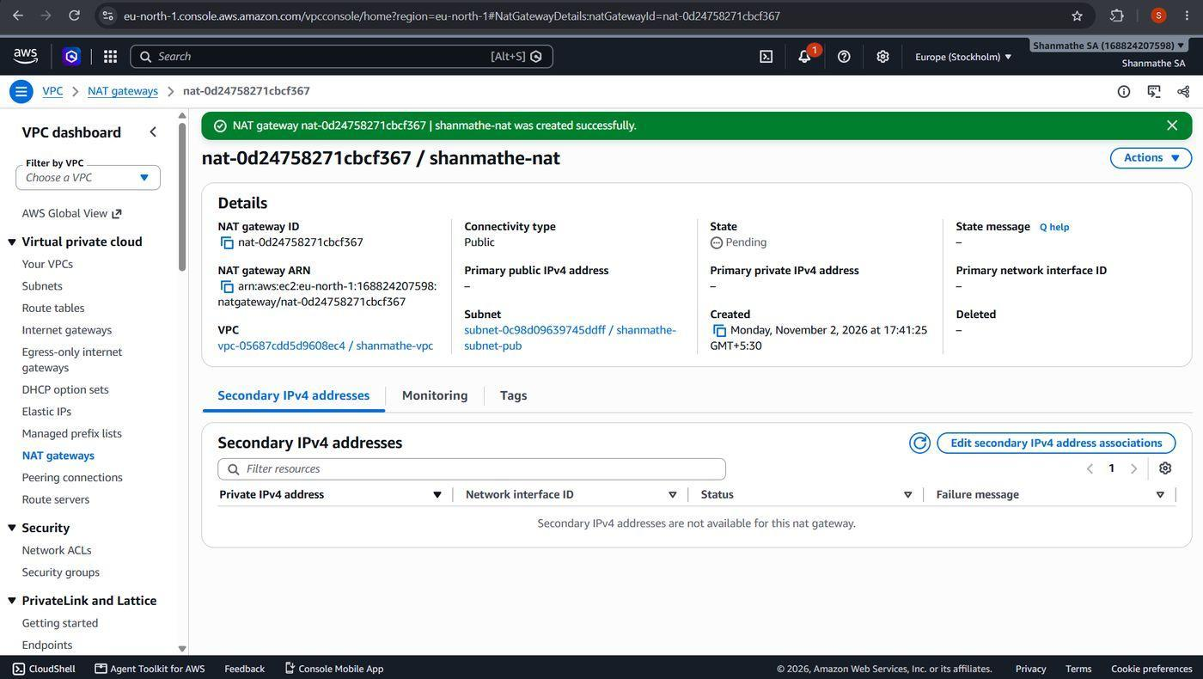

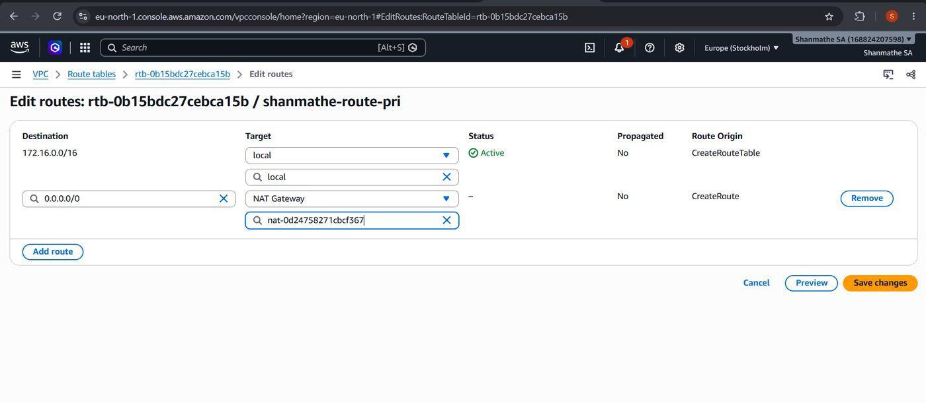

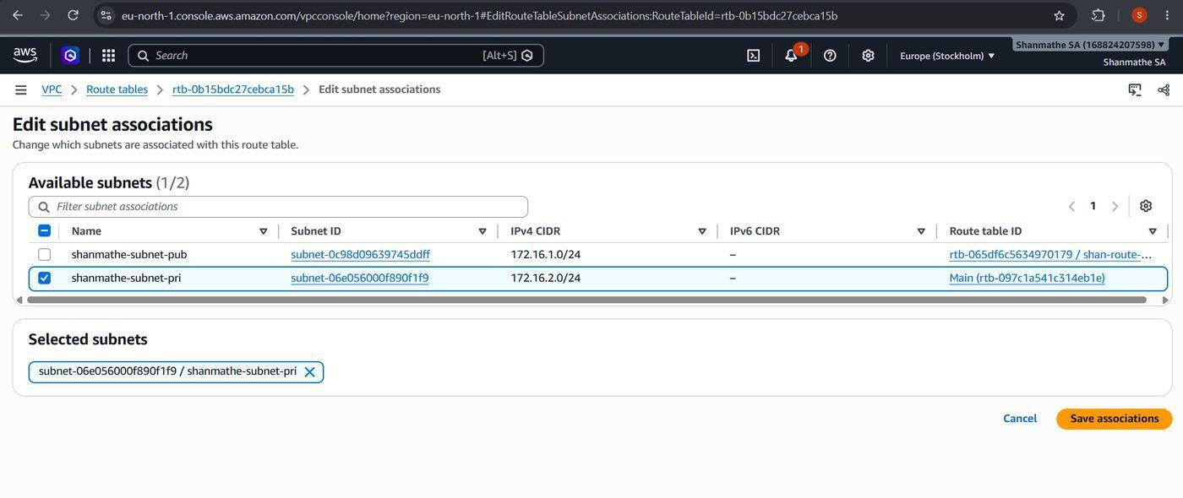

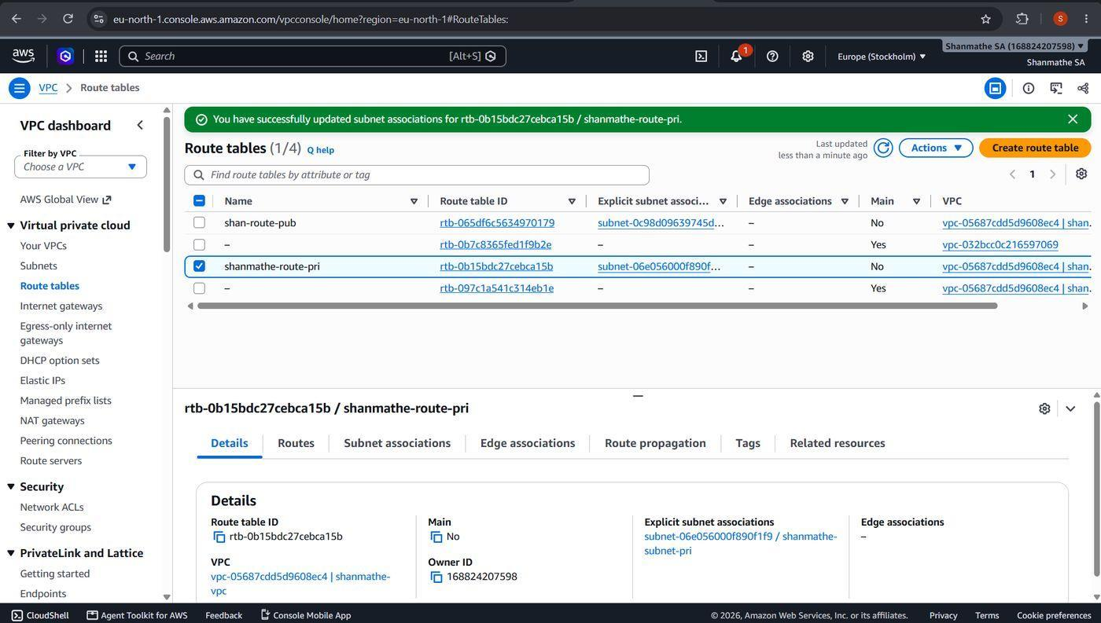

Security Groups
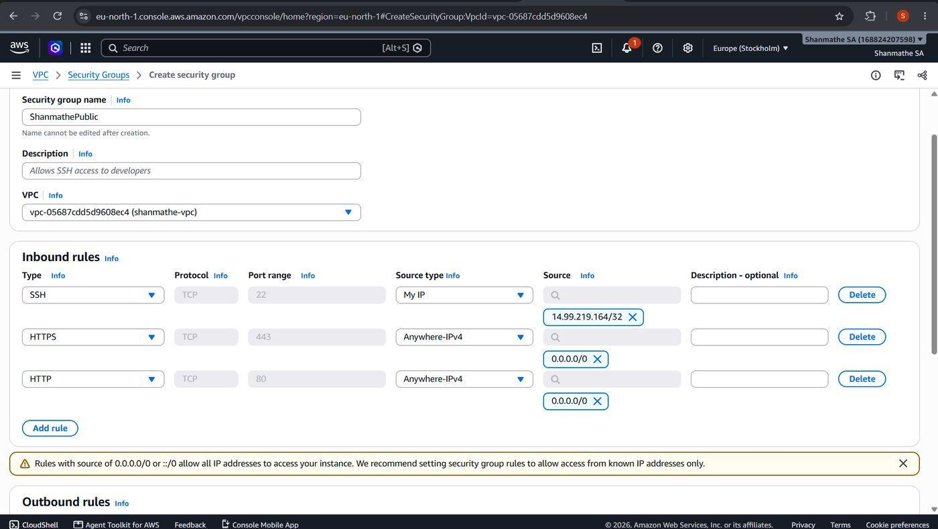

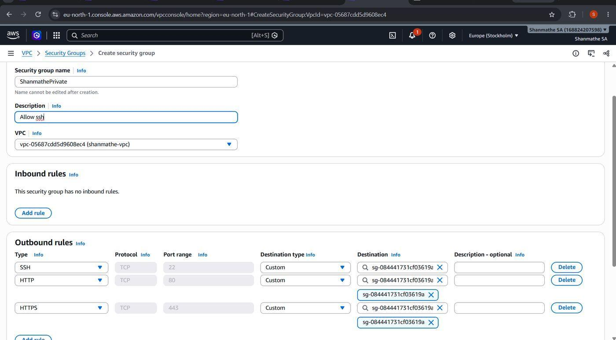

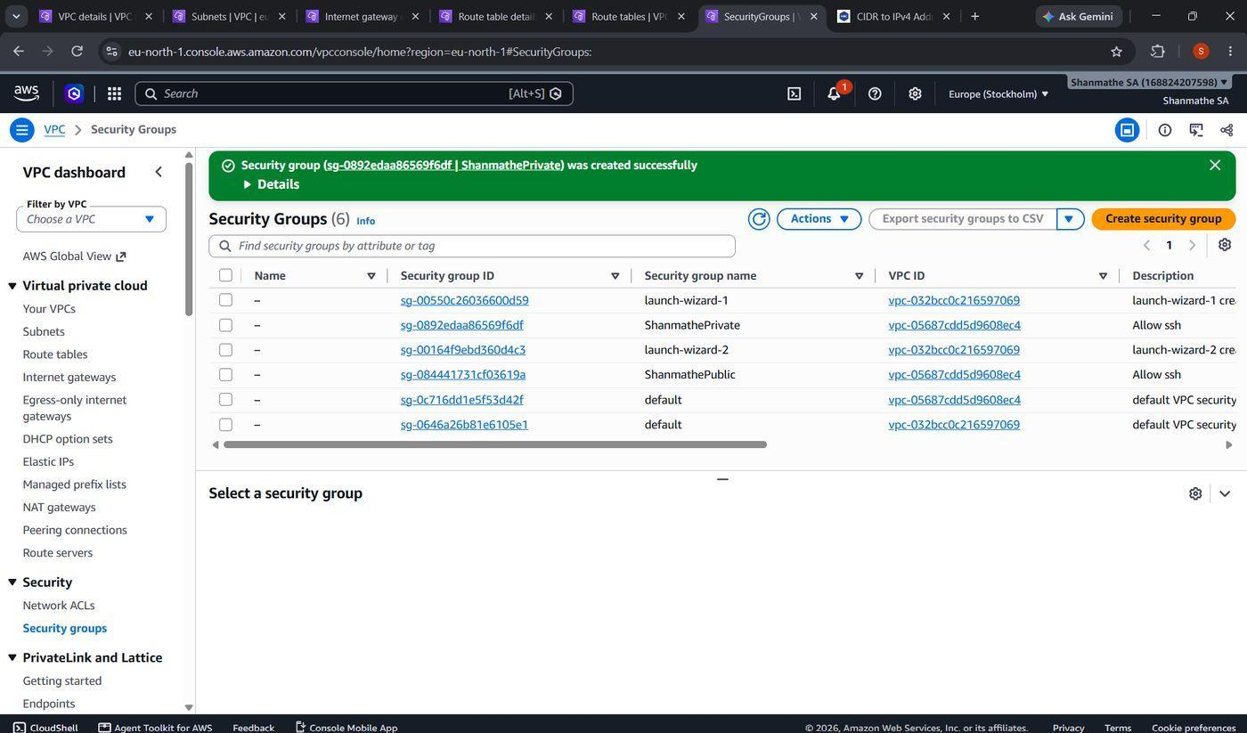

Launch Public EC2 Instance
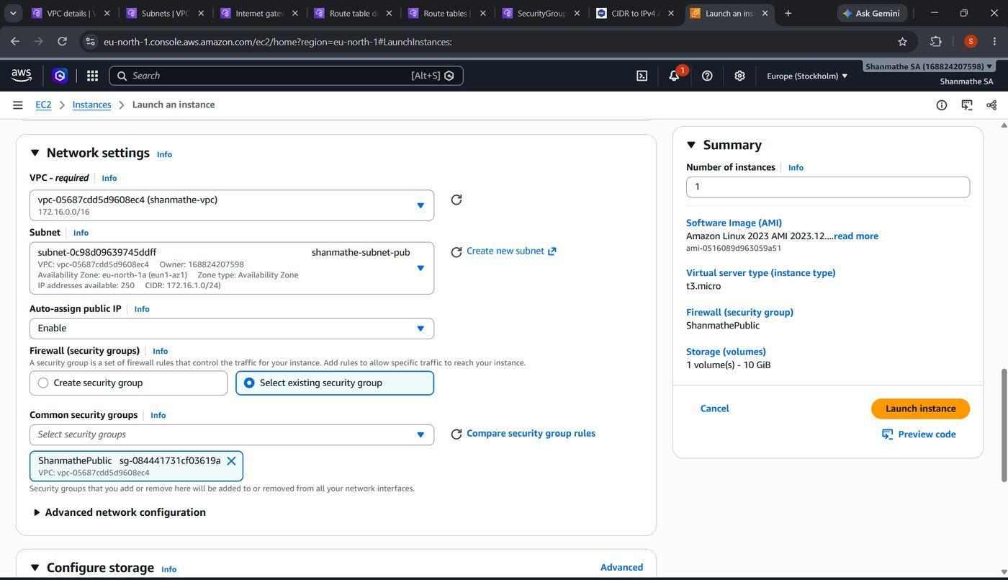

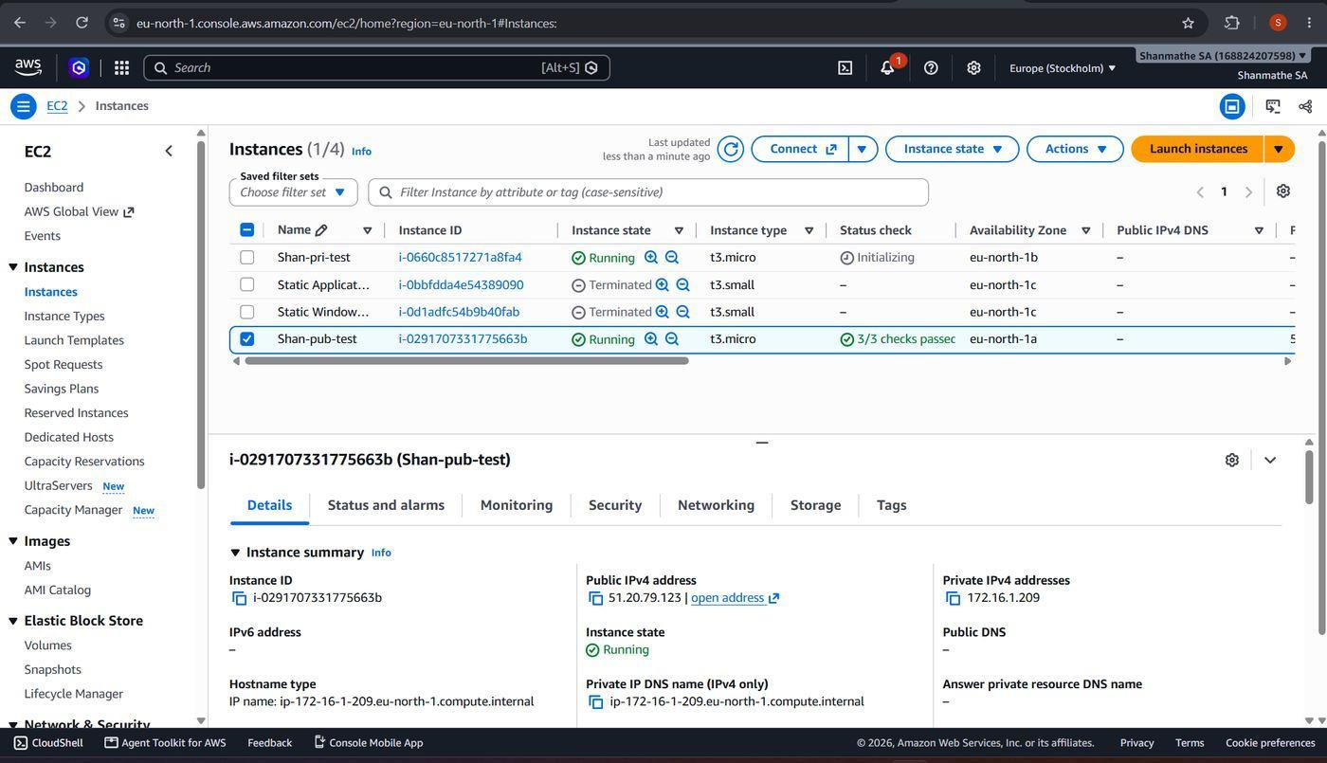

Install and Test Web Server on Public Instance
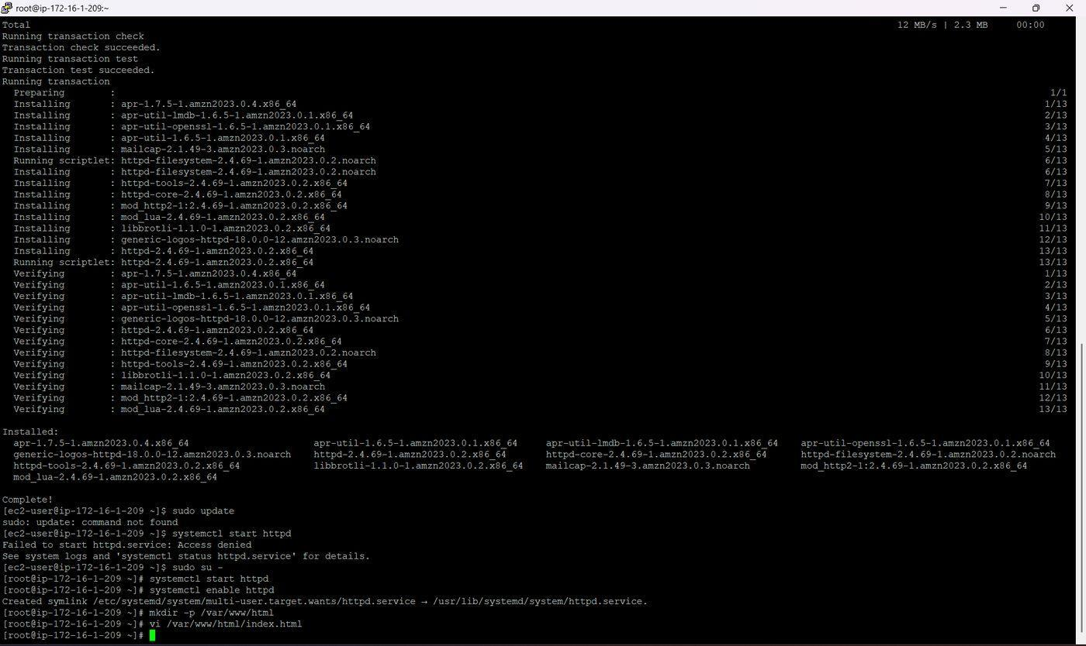

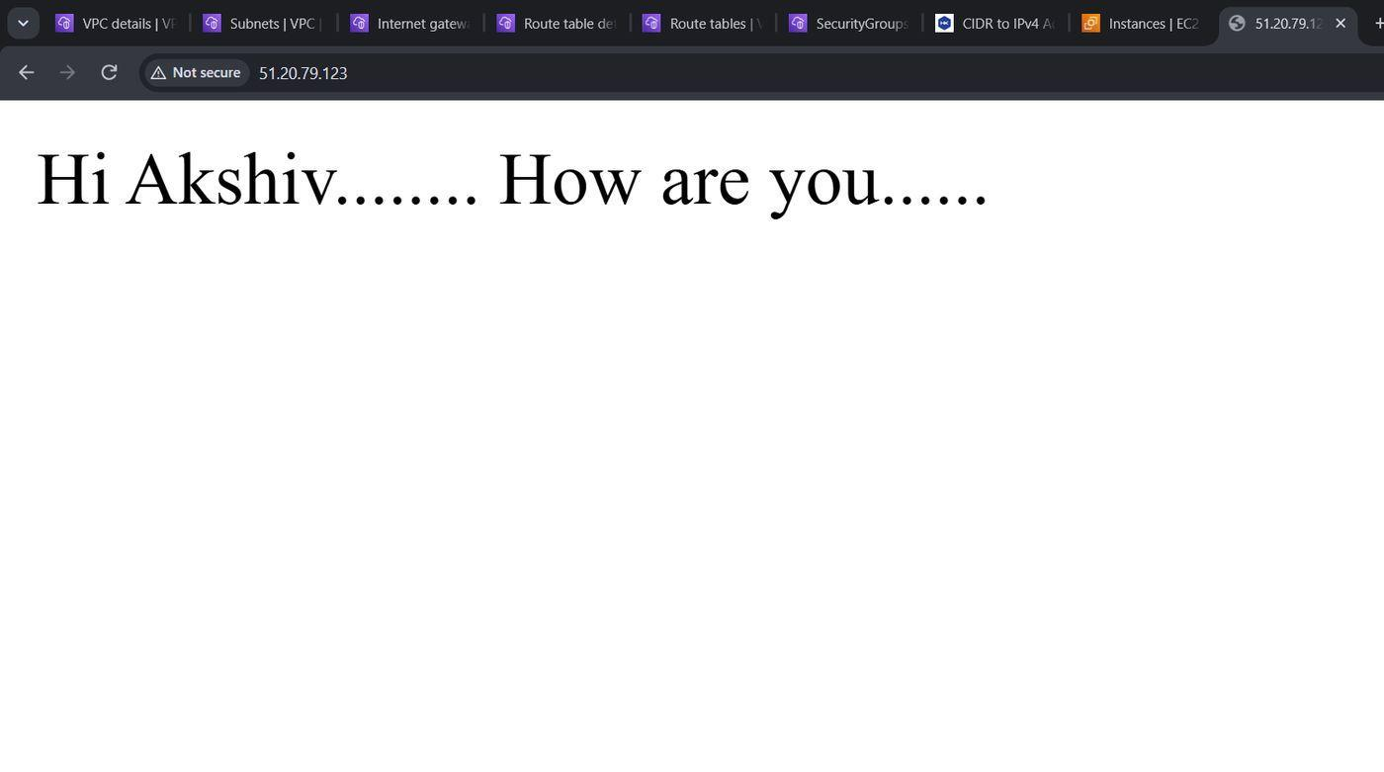

Private EC2 Instance Setup
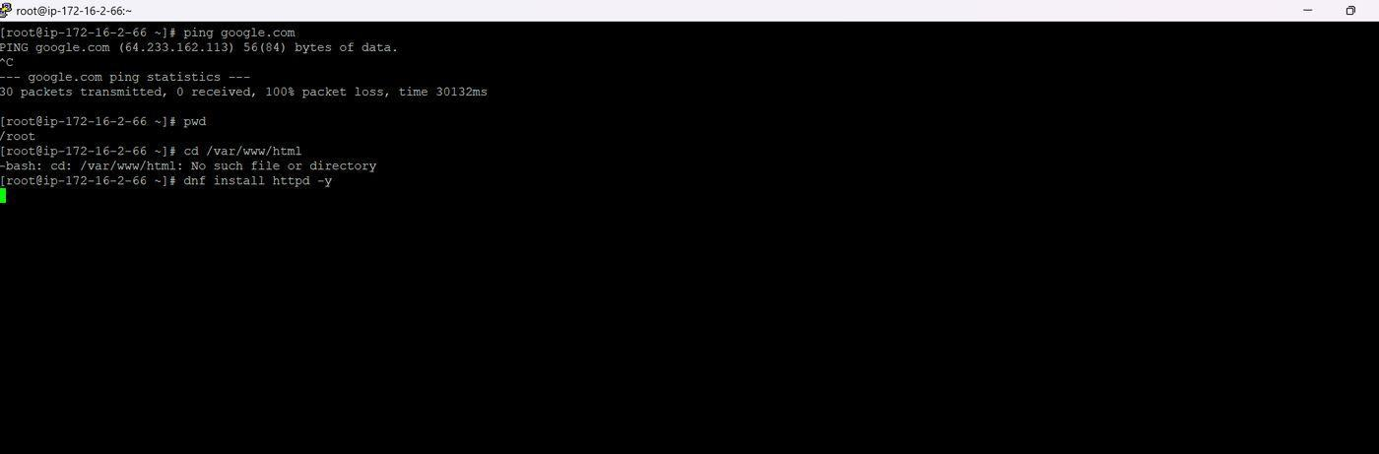

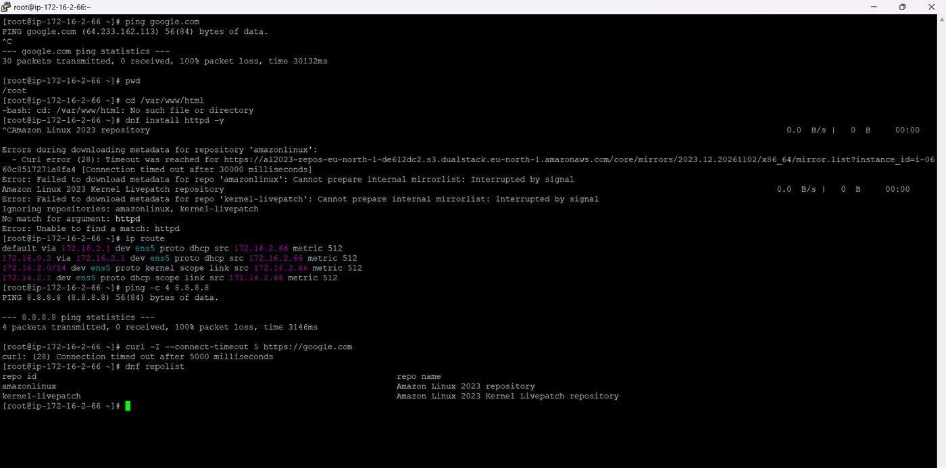
Figure 59. Troubleshooting connectivity
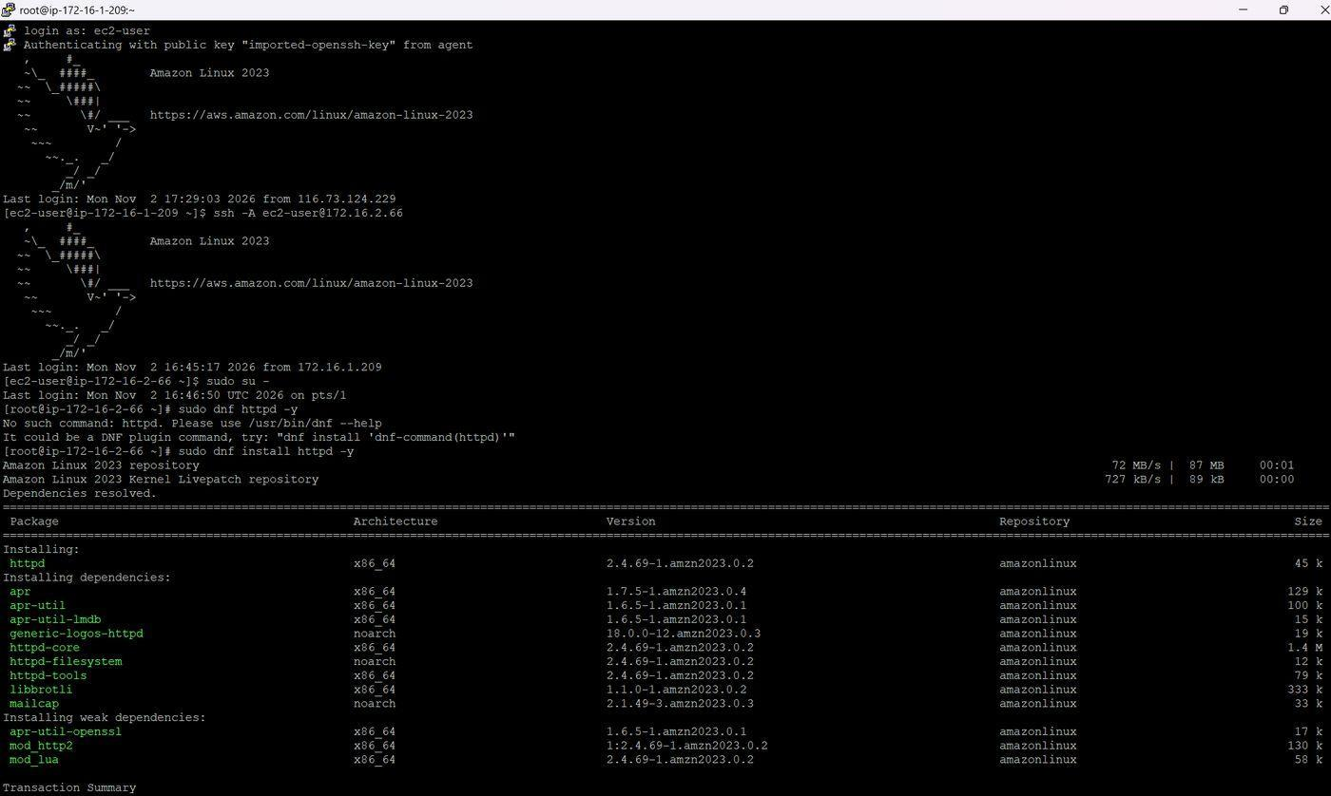
Figure 60. Installing httpd through the public instance

Reverse Proxy Configuration and Verification
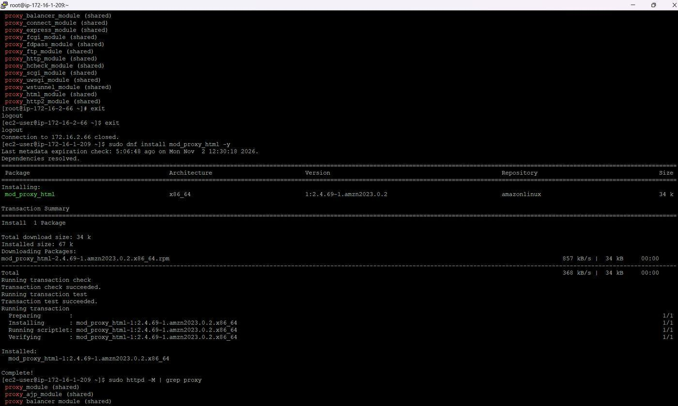
Figure 61. Enabling the proxy modules

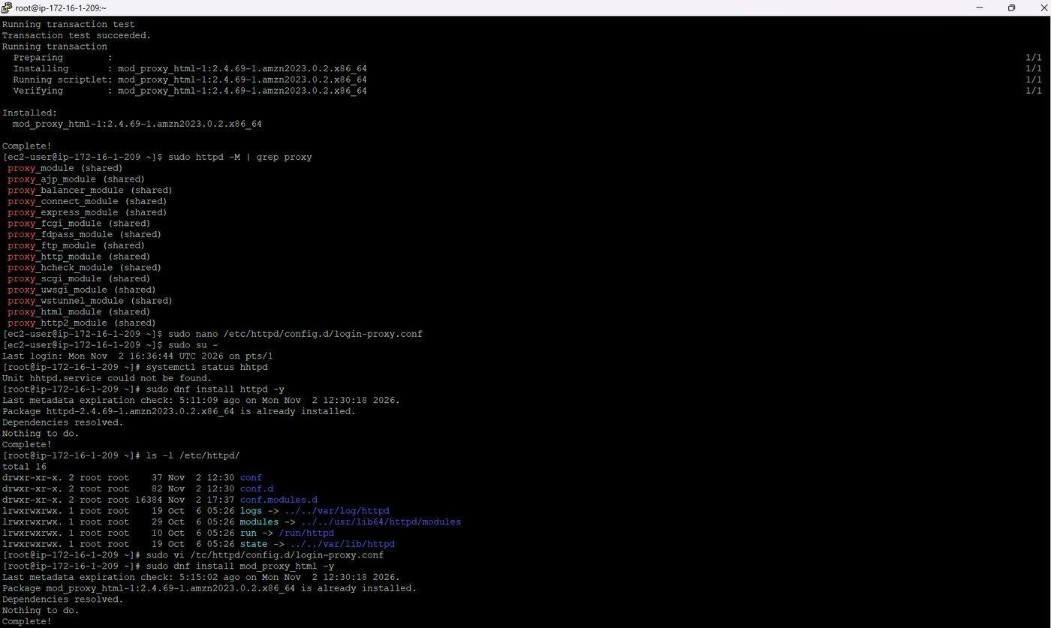
Figure 62. Creating the proxy configuration file

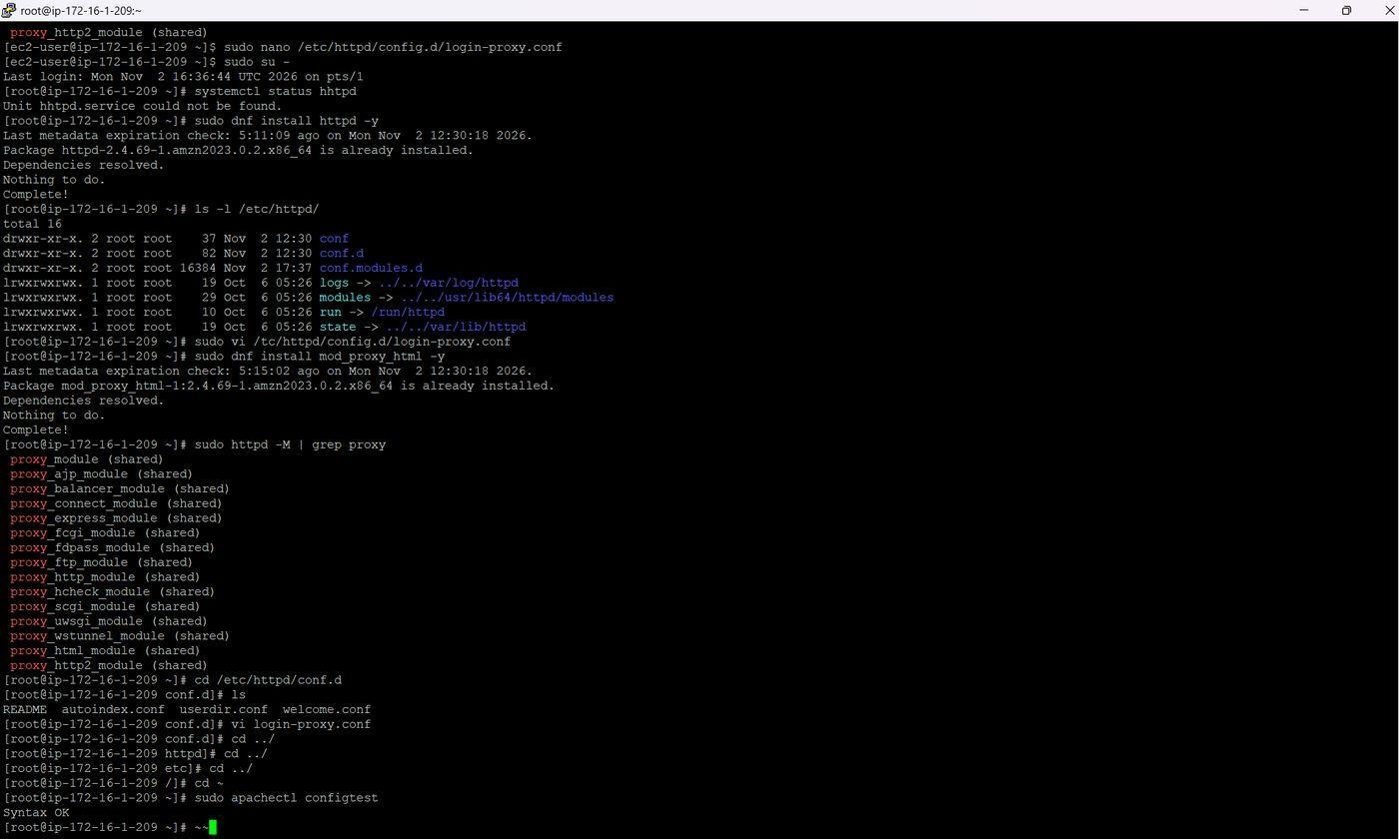
Figure 63. Editing and testing the configuration
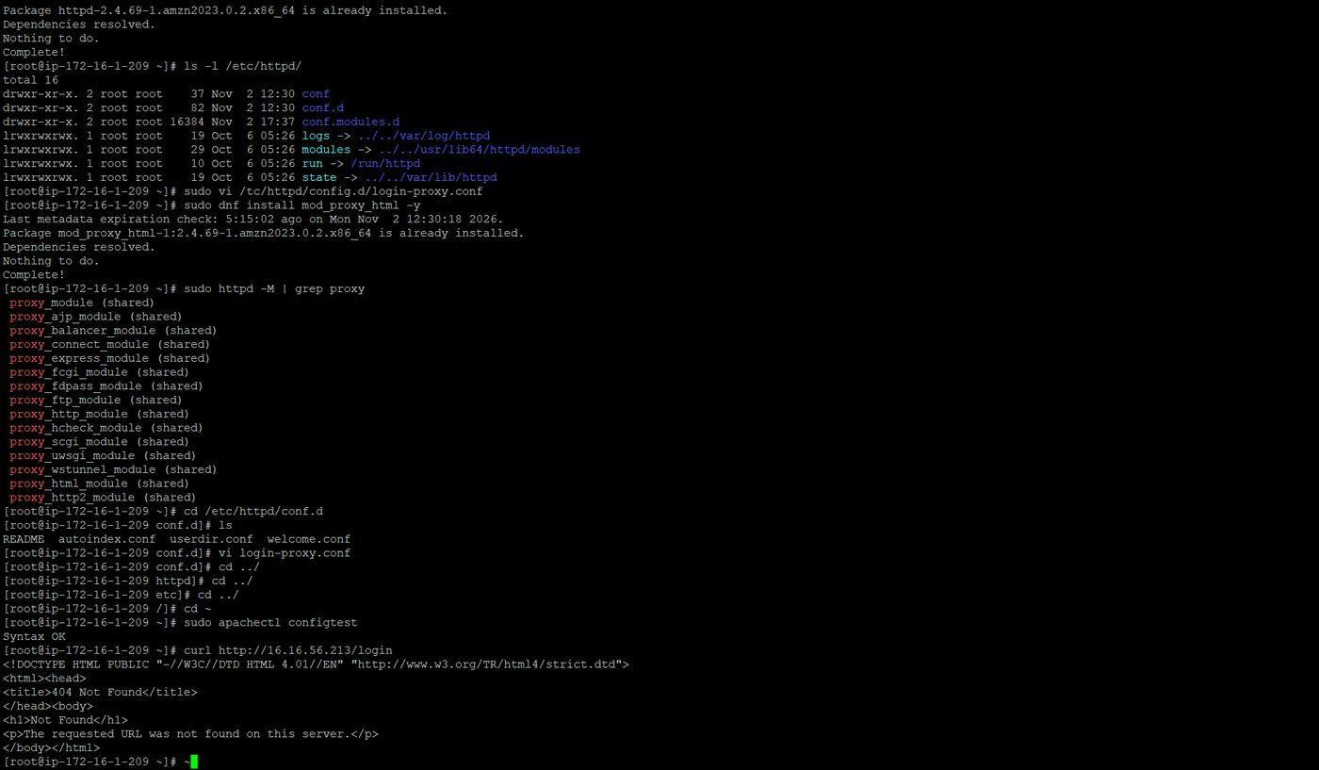
Figure 64. First test returns 404

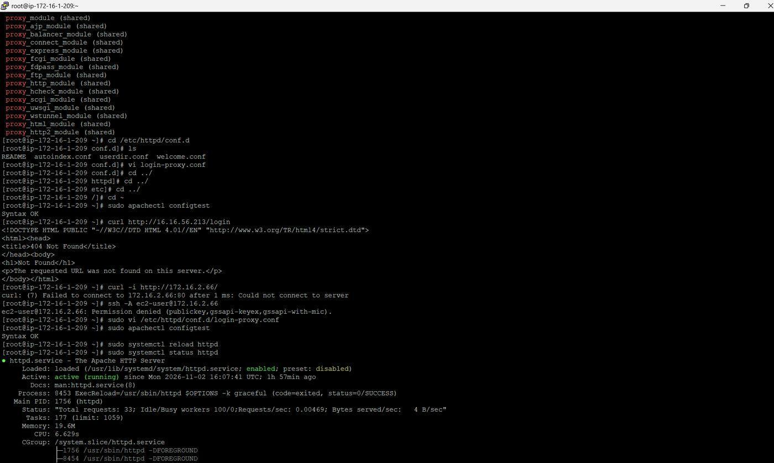
Figure 65. Debugging the private connection


